

Survey on

Project Management Software Tools

In Use in Agencies

December, 2013

Table of Contents

1. Executive Summary 3
2. Summary of Responses – All Agencies 7
3. Summary of Responses – Agencies with Up to 50 Employees 26
4. Summary of Responses – Agencies with 51 to 100 Employees 42
5. Summary of Responses – Agencies with 101 to 300 employees 58
6. Summary of Responses – Agencies with More Than 300 Employees 74

Survey on

Project Management Software Tools

(December, 2013)

The purpose of this survey was to collect information on software tools in use in 4A’s agencies for the different components of project management.

**I. Executive Summary**

We had 80 agencies respond to the survey. The breakdown of the agencies is shown below.

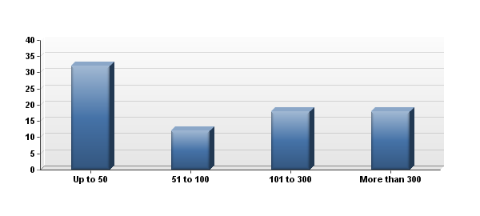

|  |  |  |  |  |  |  |
| --- | --- | --- | --- | --- | --- | --- |
| # | # of Employees | |  |  | | --- | --- | |  |  | | Response | % |
| 1 | Up to 50 | |  |  | | --- | --- | |  |  | | 32 | 40% |
| 2 | 51 to 100 | |  |  | | --- | --- | |  |  | | 12 | 15% |
| 3 | 101 to 300 | |  |  | | --- | --- | |  |  | | 18 | 23% |
| 4 | More than 300 | |  |  | | --- | --- | |  |  | | 18 | 23% |
|  | Total |  | 80 | 100% |

**I. Executive Summary** (continued)

# There are many different aspects to project management. For the purpose of this survey, we have broken down project management into the components listed below, and we asked agencies what software tools, if any, they used for the various components.

# Project Workflow

* Track all open projects
* Track agency processes and procedures
* Resource allocation; assignment of staff; workflow accountability
* Task Lists for employees, based off of project schedules; staff to-dos
* Project scope management
* Project file management; version control
* Run reports to support/evaluate agency scope of work (planned projects vs. actual)
* Generate reports to determine volume of different project types (imedia vs. print, for example)
* Generate status reports by client, product, person or other variable

The most popular tools for project workflow were spreadsheet (58%), Basecamp (33%), and Advantage (Webvantage) (28%).

# Project Time Management

* Establish and track timing guidelines
* Centralized Project Schedules
* Oversee the project lifecycle to track progress and make adjustments
* Calendar

The most popular tools for project time management were spreadsheet (42%), and Advantage (Webvantage) (24%).

**I. Executive Summary** (continued)

# Project Collaboration & Approvals

* Collaborate with clients and secure approvals at all stages
* Status reporting
* Collaborate with vendors
* Collaborate internally, secure feedback for changes and secure approvals at all stages

The most popular tools for project collaboration and approvals were agency email system (40%), Basecamp (34%), and spreadsheet (33%).

# Project Financial Management

* Prepare estimates, establish budgets
* Track estimates to actual costs
* Employee timekeeping for billing
* Run reports for use by Finance (open and closed projects, percentage completion of projects, and so forth)

The most popular tools for project financial management were spreadsheet (47%), agency accounting system (30%), and Advantage (Webvantage) (30%).

# Internal Project Communications

* Establish centralized communications to ensure all team members receive timely and appropriate project information
* Real-time status to the project team on project tasks

The most popular tools for internal project communications were agency email system (46%), and Basecamp (26%).

# Project Conclusion: Saving Project Files

* Maintenance/organization of all project files
* Store project files for future reference

The most popular tool for project conclusion was “a proprietary system created by the agency” (37%).

**I. Executive Summary** (continued)

# Data Asset Management

* Generate asset lists
* Store all project digital assets and asset metadata in a searchable database
* Store usage rights information about assets

The most popular tools for digital asset management were “a proprietary system created by the agency” (33%) and Xinet (23%).

The major conclusion is that agencies use a wide variety of software tools for different aspects of project management. Many tools are good for certain tasks in project management and not good for others. Agencies use the tools that they find are best suited for the task at hand.

No one has found a tool that does everything well.

Many tools are overly complicated and not useful in the fast-paced world of agency project management. Other tools are too simple; not robust enough for agency needs.

Some tools work well for some agencies but do not work well for others; reinforcing the fact that agency needs in this area vary widely.

There is no way to determine what tools would work best for any given agency.

We asked agencies for their overall comments on project management software tools. Their responses were illuminating and are presented in Question #15 in the All Agencies summary section, Question # 15 is on page 22.

* * * *

*The following report provides a detailed summary of the agency responses and also shows the responses in four different agency size groups.*

**II. Summary of Responses – All Agencies**

1. Do you use any software tools for any aspects of project workflow?

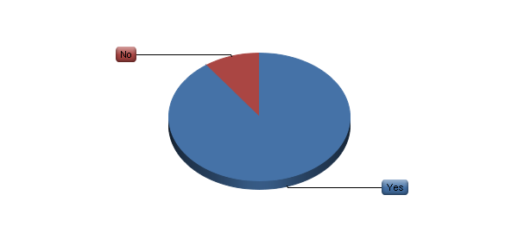

|  |  |  |  |  |  |  |
| --- | --- | --- | --- | --- | --- | --- |
| # | Answer | |  |  | | --- | --- | |  |  | | Response | % |
| 1 | Yes | |  |  | | --- | --- | |  |  | | 72 | 90% |
| 2 | No | |  |  | | --- | --- | |  |  | | 8 | 10% |
|  | Total |  | 80 | 100% |

**II. Summary of Responses – All Agencies (continued)**

2. What software tools do you use for project workflow? (please choose all that apply)

|  |  |  |  |  |  |  |
| --- | --- | --- | --- | --- | --- | --- |
| # | Answer | |  |  | | --- | --- | |  |  | | Response | % |
| 1 | Proprietary system created by the agency | |  |  | | --- | --- | |  |  | | 14 | 19% |
| 2 | Spreadsheet | |  |  | | --- | --- | |  |  | | 42 | 58% |
| 3 | Advantage (Webvantage) Software | |  |  | | --- | --- | |  |  | | 20 | 28% |
| 4 | Basecamp | |  |  | | --- | --- | |  |  | | 24 | 33% |
| 5 | Clients & Profits | |  |  | | --- | --- | |  |  | | 9 | 13% |
| 6 | Function Point | |  |  | | --- | --- | |  |  | | 0 | 0% |
| 7 | JIRA (Atlassian) | |  |  | | --- | --- | |  |  | | 10 | 14% |
| 8 | MicroSoft Project | |  |  | | --- | --- | |  |  | | 17 | 24% |
| 9 | MicroSoft SharePoint | |  |  | | --- | --- | |  |  | | 11 | 15% |
| 10 | MyProject | |  |  | | --- | --- | |  |  | | 0 | 0% |
| 11 | SocialBridge | |  |  | | --- | --- | |  |  | | 1 | 1% |
| 12 | Streamtime | |  |  | | --- | --- | |  |  | | 0 | 0% |
| 13 | Workamajig | |  |  | | --- | --- | |  |  | | 12 | 17% |
| 14 | Other (please explain) | |  |  | | --- | --- | |  |  | | 17 | 24% |

|  |
| --- |
| Other Tools for Project Workflow |
| We also work with Farmer & Co to track scope. They have a custom tool. |
| Alfresco |
| Todoist, google docs. |
| A customized version of Job Charge; also FastTrack |
| Asana |
| Request Tracker (RT), Box, Wiki |
| Confluence (Atlassian product) – two agencies |
| CurrentTrack |
| Salesforce |
| Sometimes shared Google Docs are Smart Sheet |
| Timefox |
| Affinity Live (potentially --being considered) |
| EAS |
| Written lists in MS Word document |
| We have purchased Workamajig but have not rolled it out yet. |
| Silent Partner |

**II. Summary of Responses – All Agencies (continued)**

3. Do you use any software tools for any aspects of project time management?

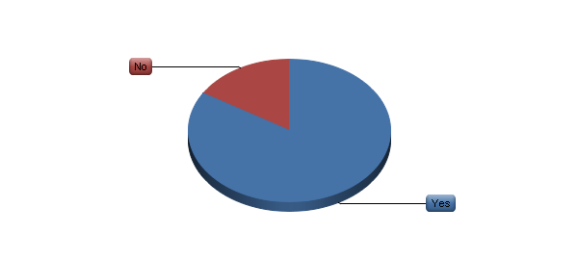

|  |  |  |  |  |  |  |
| --- | --- | --- | --- | --- | --- | --- |
| # | Answer | |  |  | | --- | --- | |  |  | | Response | % |
| 1 | Yes | |  |  | | --- | --- | |  |  | | 67 | 84% |
| 2 | No | |  |  | | --- | --- | |  |  | | 13 | 16% |
|  | Total |  | 80 | 100% |

**II. Summary of Responses – All Agencies (continued)**

4. What software tools do you use for project time management? (please choose all that apply)

|  |  |  |  |  |  |  |
| --- | --- | --- | --- | --- | --- | --- |
| # | Answer | |  |  | | --- | --- | |  |  | | Response | % |
| 1 | Proprietary system created by the agency | |  |  | | --- | --- | |  |  | | 13 | 19% |
| 2 | Spreadsheet | |  |  | | --- | --- | |  |  | | 28 | 42% |
| 3 | Advantage (Webvantage) Software | |  |  | | --- | --- | |  |  | | 16 | 24% |
| 4 | Basecamp | |  |  | | --- | --- | |  |  | | 6 | 9% |
| 5 | Clients & Profits | |  |  | | --- | --- | |  |  | | 6 | 9% |
| 6 | Function Point | |  |  | | --- | --- | |  |  | | 0 | 0% |
| 7 | JIRA (Atlassian) | |  |  | | --- | --- | |  |  | | 4 | 6% |
| 8 | MicroSoft Project | |  |  | | --- | --- | |  |  | | 13 | 19% |
| 9 | MicroSoft SharePoint | |  |  | | --- | --- | |  |  | | 5 | 7% |
| 10 | MyProject | |  |  | | --- | --- | |  |  | | 0 | 0% |
| 11 | SocialBridge | |  |  | | --- | --- | |  |  | | 0 | 0% |
| 12 | Streamtime | |  |  | | --- | --- | |  |  | | 0 | 0% |
| 13 | Workamajig | |  |  | | --- | --- | |  |  | | 11 | 16% |
| 14 | Other (please explain) | |  |  | | --- | --- | |  |  | | 12 | 18% |

|  |
| --- |
| Other Tools for Project Time Management |
| FastTrack |
| Asana |
| Smartsheet |
| CurrentTrack |
| Salesforce |
| Timefox |
| Sage 50 |
| We track hours against budget using Quickbooks Timer, and Quickbooks to produce reports |
| Prism |
| We have purchased Workamajig but have not rolled it out yet. |
| Silent Partner |
| Intervals |

**II. Summary of Responses – All Agencies (continued)**

5. Do you use any software tools for any aspects of project collaboration and approvals?

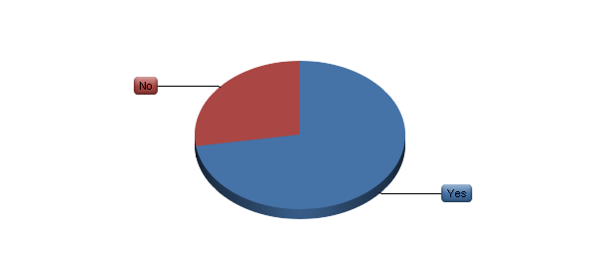

|  |  |  |  |  |  |  |
| --- | --- | --- | --- | --- | --- | --- |
| # | Answer | |  |  | | --- | --- | |  |  | | Response | % |
| 1 | Yes | |  |  | | --- | --- | |  |  | | 58 | 73% |
| 2 | No | |  |  | | --- | --- | |  |  | | 22 | 28% |
|  | Total |  | 80 | 100% |

**II. Summary of Responses – All Agencies (continued)**

6. What software tools do you use for project collaboration and approvals? (please choose all that apply)

|  |  |  |  |  |  |  |
| --- | --- | --- | --- | --- | --- | --- |
| # | Answer | |  |  | | --- | --- | |  |  | | Response | % |
| 1 | Proprietary system created by the agency | |  |  | | --- | --- | |  |  | | 7 | 12% |
| 2 | Spreadsheet | |  |  | | --- | --- | |  |  | | 19 | 33% |
| 3 | Advantage (Webvantage) Software | |  |  | | --- | --- | |  |  | | 8 | 14% |
| 4 | Basecamp | |  |  | | --- | --- | |  |  | | 20 | 34% |
| 5 | Clients & Profits | |  |  | | --- | --- | |  |  | | 1 | 2% |
| 6 | Function Point | |  |  | | --- | --- | |  |  | | 0 | 0% |
| 7 | JIRA (Atlassian) | |  |  | | --- | --- | |  |  | | 4 | 7% |
| 8 | MicroSoft Project | |  |  | | --- | --- | |  |  | | 0 | 0% |
| 9 | MicroSoft SharePoint | |  |  | | --- | --- | |  |  | | 5 | 9% |
| 10 | MyProject | |  |  | | --- | --- | |  |  | | 0 | 0% |
| 11 | SocialBridge | |  |  | | --- | --- | |  |  | | 1 | 2% |
| 12 | Streamtime | |  |  | | --- | --- | |  |  | | 0 | 0% |
| 13 | Workamajig | |  |  | | --- | --- | |  |  | | 8 | 14% |
| 14 | Other (please explain) | |  |  | | --- | --- | |  |  | | 25 | 43% |
| 15 | Agency email system | |  |  | | --- | --- | |  |  | | 23 | 40% |

**II. Summary of Responses – All Agencies (continued)**

|  |
| --- |
| Other Tools for Collaboration & Approvals |
| Secure File Share |
| ProofHQ for creative proofing and approval |
| Dalim |
| This is a mix, based on client team/clients |
| Alfresco |
| Xinet / Web Native, Wiredrive (for broadcast) |
| Asana |
| DropBox |
| Box – two agencies |
| Box, Proof HQ |
| Our soft proofing system for color and content is called SmartView and it is powered by Kodak Approval. |
| CurrentTrack |
| Network drive, printed routing, this is an area we are looking to improve. approvals are still very manual. |
| Proprietary system created by client |
| Google docs |
| Salesforce |
| Agency extranet |
| Confluence (Atlassian) – two agencies |
| Editorially for content collaboration and approval. Also Google docs. |
| Smartsheet with one client |
| Email |
| Silent Partner |

**II. Summary of Responses – All Agencies (continued)**

7. Do you use any software tools for any aspects of project financial management?

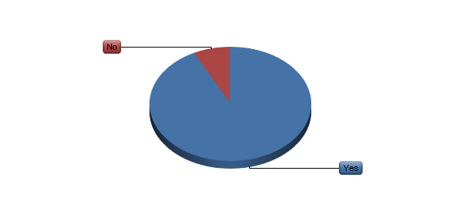

|  |  |  |  |  |  |  |
| --- | --- | --- | --- | --- | --- | --- |
| # | Answer | |  |  | | --- | --- | |  |  | | Response | % |
| 1 | Yes | |  |  | | --- | --- | |  |  | | 74 | 93% |
| 2 | No | |  |  | | --- | --- | |  |  | | 6 | 8% |
|  | Total |  | 80 | 100% |

**II. Summary of Responses – All Agencies (continued)**

8. What software tools do you use for project financial management? (please choose all that apply)

|  |  |  |  |  |  |  |
| --- | --- | --- | --- | --- | --- | --- |
| # | Answer | |  |  | | --- | --- | |  |  | | Response | % |
| 1 | Agency accounting system | |  |  | | --- | --- | |  |  | | 22 | 30% |
| 2 | Proprietary system created by the agency | |  |  | | --- | --- | |  |  | | 9 | 12% |
| 3 | Spreadsheet | |  |  | | --- | --- | |  |  | | 35 | 47% |
| 4 | Advantage (Webvantage) Software | |  |  | | --- | --- | |  |  | | 22 | 30% |
| 5 | Basecamp | |  |  | | --- | --- | |  |  | | 0 | 0% |
| 6 | Clients & Profits | |  |  | | --- | --- | |  |  | | 9 | 12% |
| 7 | Function Point | |  |  | | --- | --- | |  |  | | 0 | 0% |
| 8 | JIRA (Atlassian) | |  |  | | --- | --- | |  |  | | 0 | 0% |
| 9 | MicroSoft Project | |  |  | | --- | --- | |  |  | | 0 | 0% |
| 10 | MicroSoft SharePoint | |  |  | | --- | --- | |  |  | | 0 | 0% |
| 11 | MyProject | |  |  | | --- | --- | |  |  | | 0 | 0% |
| 12 | SocialBridge | |  |  | | --- | --- | |  |  | | 0 | 0% |
| 13 | Streamtime | |  |  | | --- | --- | |  |  | | 0 | 0% |
| 14 | Workamajig | |  |  | | --- | --- | |  |  | | 12 | 16% |
| 15 | Other (please explain) | |  |  | | --- | --- | |  |  | | 13 | 18% |

|  |
| --- |
| Other Tools for Project Financial Management |
| We use the Advantage Finanical software and export our reports |
| Google docs. |
| EAS and Cognos |
| EAS – two agencies |
| Mediaplex |
| QuickBooks |
| CurrentTrack |
| Timefox |
| Solomon |
| Quickbooks helps us state and track use of project budgets, with spreadsheet usage. |
| We use our financial/timesheet system, currently eSilent Partner. We will be switching to Workamajig in the spring. |
| Intervals |

**II. Summary of Responses – All Agencies (continued)**

9. Do you use any software tools for any aspects of internal project communications?

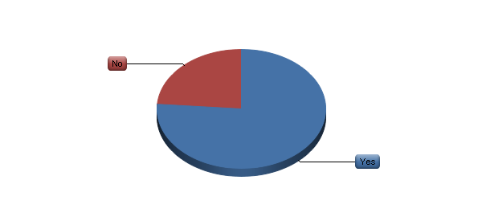

|  |  |  |  |  |  |  |
| --- | --- | --- | --- | --- | --- | --- |
| # | Answer | |  |  | | --- | --- | |  |  | | Response | % |
| 1 | Yes | |  |  | | --- | --- | |  |  | | 61 | 76% |
| 2 | No | |  |  | | --- | --- | |  |  | | 19 | 24% |
|  | Total |  | 80 | 100% |

**II. Summary of Responses – All Agencies (continued)**

10. What software tools do you use for internal project communications? (please choose all that apply)

|  |  |  |  |  |  |  |
| --- | --- | --- | --- | --- | --- | --- |
| # | Answer | |  |  | | --- | --- | |  |  | | Response | % |
| 1 | Agency email system | |  |  | | --- | --- | |  |  | | 28 | 46% |
| 2 | Proprietary system created by the agency | |  |  | | --- | --- | |  |  | | 9 | 15% |
| 3 | Spreadsheet | |  |  | | --- | --- | |  |  | | 14 | 23% |
| 4 | Advantage (Webvantage) Software | |  |  | | --- | --- | |  |  | | 10 | 16% |
| 5 | Basecamp | |  |  | | --- | --- | |  |  | | 16 | 26% |
| 6 | Clients & Profits | |  |  | | --- | --- | |  |  | | 4 | 7% |
| 7 | Function Point | |  |  | | --- | --- | |  |  | | 0 | 0% |
| 8 | JIRA (Atlassian) | |  |  | | --- | --- | |  |  | | 4 | 7% |
| 9 | MicroSoft Project | |  |  | | --- | --- | |  |  | | 1 | 2% |
| 10 | MicroSoft SharePoint | |  |  | | --- | --- | |  |  | | 6 | 10% |
| 11 | MyProject | |  |  | | --- | --- | |  |  | | 0 | 0% |
| 12 | SocialBridge | |  |  | | --- | --- | |  |  | | 0 | 0% |
| 13 | Streamtime | |  |  | | --- | --- | |  |  | | 0 | 0% |
| 14 | Workamajig | |  |  | | --- | --- | |  |  | | 9 | 15% |
| 15 | Other (please explain) | |  |  | | --- | --- | |  |  | | 19 | 31% |

|  |
| --- |
| Other Tools for Internal Project Communication |
| Confluence (wiki) |
| Outlook – two agencies |
| Dalim |
| Alfresco |
| Asana |
| iChat, AIM |
| Confluence and EAS Job Change Log |
| JMS |
| Whiteboard |
| CurrentTrack |
| Salesforce |
| BOX – two agencies |
| Confluence (Atlassian) |
| Google Docs and SmartSheet |
| EAS |
| Silent Partner |

**II. Summary of Responses – All Agencies (continued)**

11. Do you use any software tools for any aspects of project conclusion?

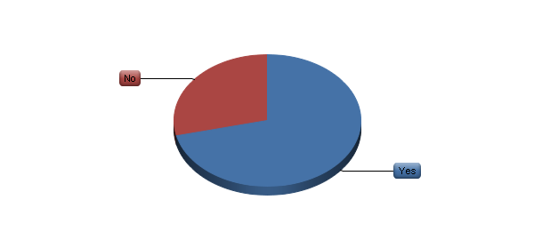

|  |  |  |  |  |  |  |
| --- | --- | --- | --- | --- | --- | --- |
| # | Answer | |  |  | | --- | --- | |  |  | | Response | % |
| 1 | Yes | |  |  | | --- | --- | |  |  | | 57 | 71% |
| 2 | No | |  |  | | --- | --- | |  |  | | 23 | 29% |
|  | Total |  | 80 | 100% |

**II. Summary of Responses – All Agencies (continued)**

12. What software tools do you use for project conclusion? (please choose all that apply)

|  |  |  |  |  |  |  |
| --- | --- | --- | --- | --- | --- | --- |
| # | Answer | |  |  | | --- | --- | |  |  | | Response | % |
| 1 | Proprietary system created by the agency | |  |  | | --- | --- | |  |  | | 21 | 37% |
| 2 | Spreadsheet | |  |  | | --- | --- | |  |  | | 3 | 5% |
| 3 | Advantage (Webvantage) Software | |  |  | | --- | --- | |  |  | | 8 | 14% |
| 4 | Basecamp | |  |  | | --- | --- | |  |  | | 8 | 14% |
| 5 | Clients & Profits | |  |  | | --- | --- | |  |  | | 2 | 4% |
| 6 | Function Point | |  |  | | --- | --- | |  |  | | 0 | 0% |
| 7 | JIRA (Atlassian) | |  |  | | --- | --- | |  |  | | 2 | 4% |
| 8 | MicroSoft Project | |  |  | | --- | --- | |  |  | | 0 | 0% |
| 9 | MicroSoft SharePoint | |  |  | | --- | --- | |  |  | | 6 | 11% |
| 10 | MyProject | |  |  | | --- | --- | |  |  | | 0 | 0% |
| 11 | SocialBridge | |  |  | | --- | --- | |  |  | | 1 | 2% |
| 12 | Streamtime | |  |  | | --- | --- | |  |  | | 0 | 0% |
| 13 | Workamajig | |  |  | | --- | --- | |  |  | | 8 | 14% |
| 14 | Other (please explain) | |  |  | | --- | --- | |  |  | | 25 | 44% |

|  |
| --- |
| Other Tools for Project Conclusion |
| Set project wrap up tasks + post mortem template |
| PPT |
| Dalim |
| BOX – two agencies |
| Files server in the local network |
| We use our servers, organized by client, by job # |
| Alfresco |
| Google docs. |
| Server – seven agencies |
| EAS, Confluence |
| JMS |
| Network drives for archiving, an area where could improve greatly in |
| Dropbox |
| Salesforce |
| Confluence (Atlassian) |
| Egnyte |
| We have a system to organize electronic files, back them up, and store them. |
| Silent Partner |

**II. Summary of Responses – All Agencies (continued)**

13. Do you use any software tools for any aspects of digital asset management?

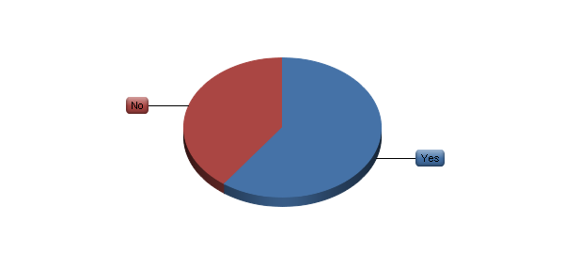

|  |  |  |  |  |  |  |
| --- | --- | --- | --- | --- | --- | --- |
| # | Answer | |  |  | | --- | --- | |  |  | | Response | % |
| 1 | Yes | |  |  | | --- | --- | |  |  | | 48 | 60% |
| 2 | No | |  |  | | --- | --- | |  |  | | 32 | 40% |
|  | Total |  | 80 | 100% |

**II. Summary of Responses – All Agencies (continued)**

14. What software tools do you use for digital asset management? (please choose all that apply)

|  |  |  |  |  |  |  |  |
| --- | --- | --- | --- | --- | --- | --- | --- |
| # | Answer | |  |  | | --- | --- | |  |  | | Response | | % |
| 1 | Proprietary system created by the agency | |  |  | | --- | --- | |  |  | | | 16 | 33% |
| 2 | Spreadsheet | |  |  | | --- | --- | |  |  | | | 9 | 19% |
| 3 | Adobe Bridge | |  |  | | --- | --- | |  |  | | | 2 | 4% |
| 4 | Advantage (Webvantage) Software | |  |  | | --- | --- | |  |  | | | 5 | 10% |
| 5 | Basecamp | |  |  | | --- | --- | |  |  | | | 4 | 8% |
| 6 | Canto Cumulus | |  |  | | --- | --- | |  |  | | | 0 | 0% |
| 7 | DiskTracker | |  |  | | --- | --- | |  |  | | | 0 | 0% |
| 8 | Extensis Portfolio | |  |  | | --- | --- | |  |  | | | 3 | 6% |
| 9 | Function Point | |  |  | | --- | --- | |  |  | | | 0 | 0% |
| 10 | JIRA (Atlassian) | |  |  | | --- | --- | |  |  | | | 0 | 0% |
| 11 | MediaBank | |  |  | | --- | --- | |  |  | | | 0 | 0% |
| 12 | MediaBeacon | |  |  | | --- | --- | |  |  | | | 1 | 2% |
| 13 | MicroSoft Project | |  |  | | --- | --- | |  |  | | | 1 | 2% |
| 14 | MicroSoft SharePoint | |  |  | | --- | --- | |  |  | | | 4 | 8% |
| 15 | MyProject | |  |  | | --- | --- | |  |  | | | 0 | 0% |
| 16 | SocialBridge | |  |  | | --- | --- | |  |  | | | 0 | 0% |
| 17 | Streamtime | |  |  | | --- | --- | |  |  | | | 0 | 0% |
| 18 | Workamajig | |  |  | | --- | --- | |  |  | | | 5 | 10% |
| 19 | Xinet | |  |  | | --- | --- | |  |  | | | 11 | 23% |
| 20 | Other (please explain) | |  |  | | --- | --- | |  |  | | | 12 | 25% |

|  |
| --- |
| Other Tools for Digital Asset Management |
| Dropbox – four agencies |
| Filemaker Database asset usage |
| Files server |
| Alfresco, AdShare |
| Also use JobCharge to gather metadata |
| Server (BOX) |
| Confluence (Atlassian) |
| We simply make lists as needed of important assets, or see them in electronic folders as final products. |

**II. Summary of Responses – All Agencies (continued)**

15. Please use this space for any additional comments on any project management software tools that you use. Are there any that are particular good? Bad? Difficult to use?

|  |
| --- |
| Comments |
| Evernote is a lifesaver for tracking things I need to remember and be able to easily search out. We use Lotus Notes for email which is a nightmare and doesn't allow for easy searchability at all. |
|  |
| We are getting ready to begin using AtTask. Wish this survey came out about 6 months from now so that we could evaluate. |
|  |
| Dalim is not recommended. We are currently exploring other options, due to the continued inability of the system to meet advertising/project management needs. |
|  |
| We are starting to work with ScreenDragon, which specializes in project workflow mgmt. We also work with ProofHQ to route mechanicals and comps with some clients. |
|  |
| Workamajig is a good tool. We are in the process of properly organizing and setting up the information after a growth period in our agency. We handle aspects of billing, scheduling, reporting, and internal communications through the system. |
|  |
| We have been live on Advantage for a year. It has dramatically changed our workflow and we are still working on changing behaviors of our employees. We don't find it perfect for digital projects and QA process. There are lots of things that are good about it; it’s more just having employees adapt. |
|  |
| Basecamp is by far the best project management collaboration tool. It is not even comparable to any other product out there. The only problem with Basecamp is it has limited functionality when you compare with Advantage & WMJ. Advantage is very complex to use and has the worst UI. WMJ is slightly better than Advantage but not by much. Google Docs are great tool when it comes to sharing with others and versioning. |
|  |
| We use different tools to address different workflow needs: Basecamp when collaboration is needed on a project; FastTrack for gantt charts and resource management (we are just setting this up actually); Job Charge to house our job numbers, assignment summaries, team assignment information, and ISCI codes and asset metadata; and Xinet for our asset management (in process of setting this up). |
|  |
| Stopped using Do.com and FunctionPoint. Neither was adequate. |
|  |

**II. Summary of Responses – All Agencies (continued)**

|  |
| --- |
| Comments |
| We are just transitioning onto Advantage (Webvantage). We have been using a proprietary system to track tasks and budgets. We also use BaseCamp for client/team collaboration and haven't found anything easier to use. We will be creating an additional client portal/extranet on SharePoint next year as well. |
|  |
| We are switching over to Social Bridge to hopefully streamline these programs and processes. |
|  |
| We ended up switching from our old Filemaker Pro system to Advantage 4 years ago. We needed it for accounting integration, but were unable to use Workamajig because it didn't integrate with a finance system we specifically have to use for one of our clients. It's OK, but they update the software so much, that now it seems like we're 15 versions behind. Feels like a ripoff. The calendar function isn't great. Hence why I have to use Basecamp for certain project calendars. Honestly, that one isn't too impressive either. It's basically a web iCal. It's not intuitive like I thought it would be. |
|  |
| We are investigating AtTask for Agency Workflow. Everyone seems to like BOX for file server. Xinet for asset storage. We just signed up with Proof HQ for eRouting and are in a pilot (4th Qtr this year and 1st Quarter last year). |
|  |
| I haven't found any single system that is good at EVERYTHING! EAS has a great job change log system, but you can only look at one job at a time. It's not good for complex schedules -- and the schedule component is what ties into resource management. EAS has a nice "estimate vs. actual" feature for managing time. But, you need to have an approved estimate in the system for that to work. Sharepoint allows you to create custom layouts so you can review status for multiple projects--and it's real time! It's not good for schedules. Confluence is amazing for a central web-based location for client information, project information but it's not the place to manage the budget. Jira is a great tool to move web work through the process. Long story short -- we use different tools for different aspects of Project Management. Whatever works best for the task at hand and whatever is the most customizable on the fly also seems to be needed. |
|  |
| Our proprietary system has become outdated and is expensive to upgrade so we are considering another alternative. |
|  |
| They tend to either be overly complicated or simple, lacking flexibility to customize to needs. |
|  |
| In the interest of full disclosure, CurrentTrack® is web-based agency management software created and marketed by Developware (developware.com), a separate company owned by several employees of our agency. |

**II. Summary of Responses – All Agencies (continued)**

|  |
| --- |
| Comments |
| We rely heavily on MS Project and Project Server/Sharpoint. This give us tremendous reporting capabilities but we need to be diligent in ensuring Project Managers maintain their plans accurately. And since MS Project can sometimes be a difficult tool to learn, the accuracy of our resourcing (who is assigned to what) can be a problem. We are heavily invested in the system and will not be changing any time soon, but agencies should know that while Project Server is powerful, it can be challenging and complex for fast paced agency project management. |
|  |
| We are currently evaluating AtTask as a piece of software to do project Management / Collaboration and Resource / Capacity Planning. |
|  |
| We started using Workamig in August 2012 after using a combination of Clients and Profits, MS Projects, a proprietary software we developed off of an Active Collab platform, excel, binders. There are parts of Workamajig that aren't flexible enough or robust enough yet for us to use effectively--like file sharing, like super crazy deadlines task management--and we are working with Workamajig on our options there. Even with things not perfect, Workamajig is a much better project management tool for us than Clients and Profits (although our finance department was not pleased with leaving C&P behind.) |
|  |
| We have not been able to successfully find one software that can do everything well. They all have a short comings which is why we need to always have separate systems/processes. |
|  |
| We utilize a system we developed with Salesforce to assist in the management of most projects. |
|  |
| Advantage is good for time entry and finance, not Project Management -- too cumbersome and time consuming. You can't change schedules as fast as schedules change! |
|  |
| I've recently been giving Collabtive a test-drive for selective internal project collaboration, management, communication, etc... as an open-source tool, it provides similar functionality to some of the paid SaaS solutions, and even has a more intuitive user interface than some. The version I've been testing is self-hosted & self-maintained, so any technical issues that arise are on me to resolve. That being said, a paid service option is available as well. |
|  |
| We also use Pivotal Tracker for projects using agile web development. |
|  |
| We've looked at a lot of these. We primarily use Workamajig for accounting, job number generation, estimates, POs, etc. It has functionality for creating project schedules, resource management, and collaboration. We found the schedules and resource management to be too dependent on employee participation in order for it to be accurate and useful, so at our size, we have opted not to use it. We're starting to look into the collaboration component, which is newer. This may be useful. I've also done collaboration demos with several other software companies (Huddle, Mavenlink, etc), but we're going to try out Workamajig first since we're already paying for it. |

**II. Summary of Responses – All Agencies (continued)**

|  |
| --- |
| Comments |
| WebVantage is not ideal for any aspect of the agency business EXCEPT for finance. It works great there so we use it for that. We work around it for everything else. |
|  |
| We use Google Docs and Basecamp to manage most ongoing projects internally and with clients. We use our server to manage and archive projects after the fact. We use Client & Profits to track time and manage invoices. We find the new Client & Profits extremely buggy and a huge waste. We are evaluating a variety of DAMs and Project Mgt systems now including Concrete 5 and Affinity Live and Workamijig. |
|  |
| Although a small agency, we would probably benefit from the regimentation that project management software would provide. I would be interested to learn what might be the best (simplest) for a small firm. |
|  |
| We have only used Basecamp for collaborative discussion and file sharing with our affiliate offices (we belong to a network of independent agencies). Like any software, we have from time to time looked at project management software but end up perceiving that it will take more time to learn to use it efficiently than the time it would save. We are probably wrong in that perception, but that's where we have left it. |
|  |
| We have used Workamajig for over 5-years and find it to be helpful in tracking project details from beginning to end. The software provides good client interfaces as well. The teaching aids are fair and could use some improvement so new associates sometimes find it difficult from a start-up standpoint. Once acclimated, the system works like a charm! |

**III. Summary of Responses – Agencies with Up to 50 Employees (32)**

**There were 32 agencies in this group.**

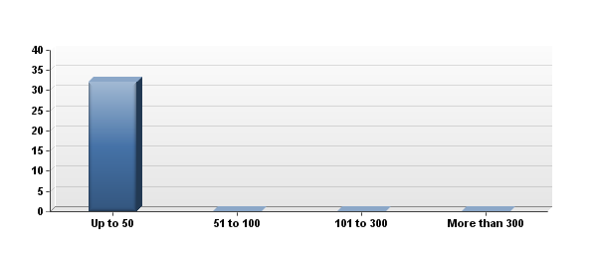

|  |  |  |  |  |  |  |
| --- | --- | --- | --- | --- | --- | --- |
| # | # of Employees | |  |  | | --- | --- | |  |  | | Response | % |
| 1 | Up to 50 | |  |  | | --- | --- | |  |  | | 32 | 100% |
| 2 | 51 to 100 | |  |  | | --- | --- | |  |  | | 0 | 0% |
| 3 | 101 to 300 | |  |  | | --- | --- | |  |  | | 0 | 0% |
| 4 | More than 300 | |  |  | | --- | --- | |  |  | | 0 | 0% |
|  | Total |  | 32 | 100% |

**III. Summary of Responses – Agencies with Up to 50 Employees (32) (continued)**

1. Do you use any software tools for any aspects of project workflow?

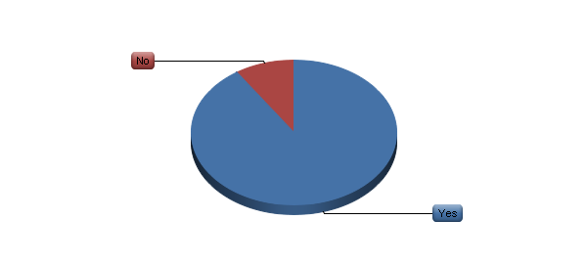

|  |  |  |  |  |  |  |
| --- | --- | --- | --- | --- | --- | --- |
| # | Answer | |  |  | | --- | --- | |  |  | | Response | % |
| 1 | Yes | |  |  | | --- | --- | |  |  | | 29 | 91% |
| 2 | No | |  |  | | --- | --- | |  |  | | 3 | 9% |
|  | Total |  | 32 | 100% |

**III. Summary of Responses – Agencies with Up to 50 Employees (32) (continued)**

2. What software tools do you use for project workflow? (please choose all that apply)

|  |  |  |  |  |  |  |
| --- | --- | --- | --- | --- | --- | --- |
| # | Answer | |  |  | | --- | --- | |  |  | | Response | % |
| 1 | Proprietary system created by the agency | |  |  | | --- | --- | |  |  | | 3 | 10% |
| 2 | Spreadsheet | |  |  | | --- | --- | |  |  | | 16 | 55% |
| 3 | Advantage (Webvantage) Software | |  |  | | --- | --- | |  |  | | 10 | 34% |
| 4 | Basecamp | |  |  | | --- | --- | |  |  | | 9 | 31% |
| 5 | Clients & Profits | |  |  | | --- | --- | |  |  | | 7 | 24% |
| 6 | Function Point | |  |  | | --- | --- | |  |  | | 0 | 0% |
| 7 | JIRA (Atlassian) | |  |  | | --- | --- | |  |  | | 0 | 0% |
| 8 | MicroSoft Project | |  |  | | --- | --- | |  |  | | 1 | 3% |
| 9 | MicroSoft SharePoint | |  |  | | --- | --- | |  |  | | 1 | 3% |
| 10 | MyProject | |  |  | | --- | --- | |  |  | | 0 | 0% |
| 11 | SocialBridge | |  |  | | --- | --- | |  |  | | 0 | 0% |
| 12 | Streamtime | |  |  | | --- | --- | |  |  | | 0 | 0% |
| 13 | Workamajig | |  |  | | --- | --- | |  |  | | 4 | 14% |
| 14 | Other (please explain) | |  |  | | --- | --- | |  |  | | 7 | 24% |

|  |
| --- |
| Other Tools for Project Workflow |
| Alfresco |
| Asana |
| CurrentTrack |
| Sometimes shared Google Docs are SmartSheet |
| Timefox |
| Affinity Live (potentially --being considered) |
| Written lists in MS Word document |

**III. Summary of Responses – Agencies with Up to 50 Employees (32) (continued)**

3. Do you use any software tools for any aspects of project time management?

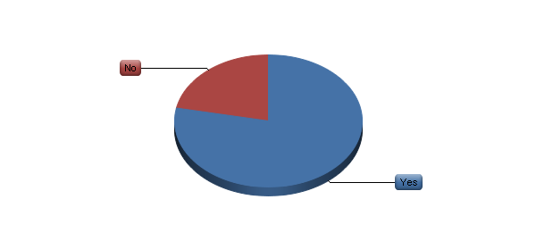

|  |  |  |  |  |  |  |
| --- | --- | --- | --- | --- | --- | --- |
| # | Answer | |  |  | | --- | --- | |  |  | | Response | % |
| 1 | Yes | |  |  | | --- | --- | |  |  | | 25 | 78% |
| 2 | No | |  |  | | --- | --- | |  |  | | 7 | 22% |
|  | Total |  | 32 | 100% |

**III. Summary of Responses – Agencies with Up to 50 Employees (32) (continued)**

4. What software tools do you use for project time management? (please choose all that apply)

|  |  |  |  |  |  |  |
| --- | --- | --- | --- | --- | --- | --- |
| # | Answer | |  |  | | --- | --- | |  |  | | Response | % |
| 1 | Proprietary system created by the agency | |  |  | | --- | --- | |  |  | | 3 | 12% |
| 2 | Spreadsheet | |  |  | | --- | --- | |  |  | | 9 | 36% |
| 3 | Advantage (Webvantage) Software | |  |  | | --- | --- | |  |  | | 6 | 24% |
| 4 | Basecamp | |  |  | | --- | --- | |  |  | | 4 | 16% |
| 5 | Clients & Profits | |  |  | | --- | --- | |  |  | | 4 | 16% |
| 6 | Function Point | |  |  | | --- | --- | |  |  | | 0 | 0% |
| 7 | JIRA (Atlassian) | |  |  | | --- | --- | |  |  | | 0 | 0% |
| 8 | MicroSoft Project | |  |  | | --- | --- | |  |  | | 1 | 4% |
| 9 | MicroSoft SharePoint | |  |  | | --- | --- | |  |  | | 1 | 4% |
| 10 | MyProject | |  |  | | --- | --- | |  |  | | 0 | 0% |
| 11 | SocialBridge | |  |  | | --- | --- | |  |  | | 0 | 0% |
| 12 | Streamtime | |  |  | | --- | --- | |  |  | | 0 | 0% |
| 13 | Workamajig | |  |  | | --- | --- | |  |  | | 3 | 12% |
| 14 | Other (please explain) | |  |  | | --- | --- | |  |  | | 6 | 24% |

|  |
| --- |
| Other Tools for Project Time Management |
| Asana |
| CurrentTrack |
| Timefox |
| Sage 50 |
| We track hours against budget using Quickbooks Timer, and Quickbooks to produce reports |
| Intervals |

**III. Summary of Responses – Agencies with Up to 50 Employees (32) (continued)**

5. Do you use any software tools for any aspects of project collaboration and approvals?

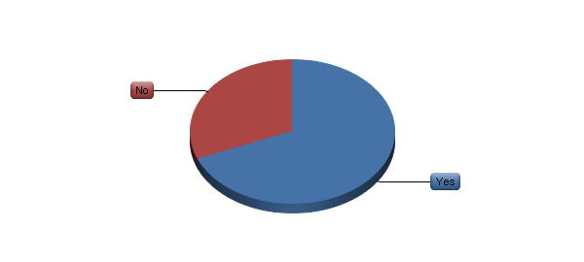

|  |  |  |  |  |  |  |
| --- | --- | --- | --- | --- | --- | --- |
| # | Answer | |  |  | | --- | --- | |  |  | | Response | % |
| 1 | Yes | |  |  | | --- | --- | |  |  | | 22 | 69% |
| 2 | No | |  |  | | --- | --- | |  |  | | 10 | 31% |
|  | Total |  | 32 | 100% |

**III. Summary of Responses – Agencies with Up to 50 Employees (32) (continued)**

6. What software tools do you use for project collaboration and approvals? (please choose all that apply)

|  |  |  |  |  |  |  |
| --- | --- | --- | --- | --- | --- | --- |
| # | Answer | |  |  | | --- | --- | |  |  | | Response | % |
| 1 | Proprietary system created by the agency | |  |  | | --- | --- | |  |  | | 1 | 5% |
| 2 | Spreadsheet | |  |  | | --- | --- | |  |  | | 9 | 41% |
| 3 | Advantage (Webvantage) Software | |  |  | | --- | --- | |  |  | | 4 | 18% |
| 4 | Basecamp | |  |  | | --- | --- | |  |  | | 9 | 41% |
| 5 | Clients & Profits | |  |  | | --- | --- | |  |  | | 1 | 5% |
| 6 | Function Point | |  |  | | --- | --- | |  |  | | 0 | 0% |
| 7 | JIRA (Atlassian) | |  |  | | --- | --- | |  |  | | 0 | 0% |
| 8 | MicroSoft Project | |  |  | | --- | --- | |  |  | | 0 | 0% |
| 9 | MicroSoft SharePoint | |  |  | | --- | --- | |  |  | | 1 | 5% |
| 10 | MyProject | |  |  | | --- | --- | |  |  | | 0 | 0% |
| 11 | SocialBridge | |  |  | | --- | --- | |  |  | | 0 | 0% |
| 12 | Streamtime | |  |  | | --- | --- | |  |  | | 0 | 0% |
| 13 | Workamajig | |  |  | | --- | --- | |  |  | | 3 | 14% |
| 14 | Other (please explain) | |  |  | | --- | --- | |  |  | | 8 | 36% |
| 15 | Agency email system | |  |  | | --- | --- | |  |  | | 11 | 50% |

|  |
| --- |
| Other Tools for Collaboration & Approvals |
| Alfresco |
| Asana |
| Dropbox |
| CurrentTrack |
| Google docs |
| Agency extranet |
| SmartSheet with one client |

**III. Summary of Responses – Agencies with Up to 50 Employees (32) (continued)**

7. Do you use any software tools for any aspects of project financial management?

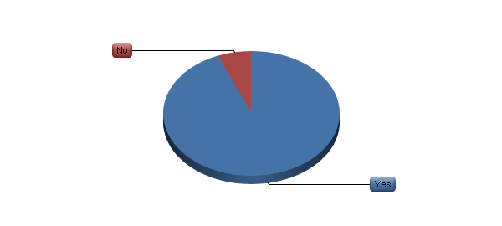

|  |  |  |  |  |  |  |
| --- | --- | --- | --- | --- | --- | --- |
| # | Answer | |  |  | | --- | --- | |  |  | | Response | % |
| 1 | Yes | |  |  | | --- | --- | |  |  | | 30 | 94% |
| 2 | No | |  |  | | --- | --- | |  |  | | 2 | 6% |
|  | Total |  | 32 | 100% |

**III. Summary of Responses – Agencies with Up to 50 Employees (32) (continued)**

8. What software tools do you use for project financial management? (please choose all that apply)

|  |  |  |  |  |  |  |
| --- | --- | --- | --- | --- | --- | --- |
| # | Answer | |  |  | | --- | --- | |  |  | | Response | % |
| 1 | Agency accounting system | |  |  | | --- | --- | |  |  | | 6 | 20% |
| 2 | Proprietary system created by the agency | |  |  | | --- | --- | |  |  | | 1 | 3% |
| 3 | Spreadsheet | |  |  | | --- | --- | |  |  | | 9 | 30% |
| 4 | Advantage (Webvantage) Software | |  |  | | --- | --- | |  |  | | 10 | 33% |
| 5 | Basecamp | |  |  | | --- | --- | |  |  | | 0 | 0% |
| 6 | Clients & Profits | |  |  | | --- | --- | |  |  | | 7 | 23% |
| 7 | Function Point | |  |  | | --- | --- | |  |  | | 0 | 0% |
| 8 | JIRA (Atlassian) | |  |  | | --- | --- | |  |  | | 0 | 0% |
| 9 | MicroSoft Project | |  |  | | --- | --- | |  |  | | 0 | 0% |
| 10 | MicroSoft SharePoint | |  |  | | --- | --- | |  |  | | 0 | 0% |
| 11 | MyProject | |  |  | | --- | --- | |  |  | | 0 | 0% |
| 12 | SocialBridge | |  |  | | --- | --- | |  |  | | 0 | 0% |
| 13 | Streamtime | |  |  | | --- | --- | |  |  | | 0 | 0% |
| 14 | Workamajig | |  |  | | --- | --- | |  |  | | 4 | 13% |
| 15 | Other (please explain) | |  |  | | --- | --- | |  |  | | 5 | 17% |

|  |
| --- |
| Other Tools for Project Financial Management |
| QuickBooks |
| CurrentTrack |
| Timefox |
| Quickbooks helps us state and track use of project budgets, with spreadsheet usage. |
| Intervals |

**III. Summary of Responses – Agencies with Up to 50 Employees (32) (continued)**

9. Do you use any software tools for any aspects of internal project communications?



|  |  |  |  |  |  |  |
| --- | --- | --- | --- | --- | --- | --- |
| # | Answer | |  |  | | --- | --- | |  |  | | Response | % |
| 1 | Yes | |  |  | | --- | --- | |  |  | | 22 | 69% |
| 2 | No | |  |  | | --- | --- | |  |  | | 10 | 31% |
|  | Total |  | 32 | 100% |

**III. Summary of Responses – Agencies with Up to 50 Employees (32) (continued)**

10. What software tools do you use for internal project communications? (please choose all that apply)

|  |  |  |  |  |  |  |
| --- | --- | --- | --- | --- | --- | --- |
| # | Answer | |  |  | | --- | --- | |  |  | | Response | % |
| 1 | Agency email system | |  |  | | --- | --- | |  |  | | 13 | 59% |
| 2 | Proprietary system created by the agency | |  |  | | --- | --- | |  |  | | 1 | 5% |
| 3 | Spreadsheet | |  |  | | --- | --- | |  |  | | 6 | 27% |
| 4 | Advantage (Webvantage) Software | |  |  | | --- | --- | |  |  | | 3 | 14% |
| 5 | Basecamp | |  |  | | --- | --- | |  |  | | 7 | 32% |
| 6 | Clients & Profits | |  |  | | --- | --- | |  |  | | 3 | 14% |
| 7 | Function Point | |  |  | | --- | --- | |  |  | | 0 | 0% |
| 8 | JIRA (Atlassian) | |  |  | | --- | --- | |  |  | | 0 | 0% |
| 9 | MicroSoft Project | |  |  | | --- | --- | |  |  | | 0 | 0% |
| 10 | MicroSoft SharePoint | |  |  | | --- | --- | |  |  | | 1 | 5% |
| 11 | MyProject | |  |  | | --- | --- | |  |  | | 0 | 0% |
| 12 | SocialBridge | |  |  | | --- | --- | |  |  | | 0 | 0% |
| 13 | Streamtime | |  |  | | --- | --- | |  |  | | 0 | 0% |
| 14 | Workamajig | |  |  | | --- | --- | |  |  | | 3 | 14% |
| 15 | Other (please explain) | |  |  | | --- | --- | |  |  | | 6 | 27% |

|  |
| --- |
| Other Tools for Internal Project Communication |
| Alfresco |
| Asana |
| Outlook calendar and tasks |
| Whiteboard |
| CurrentTrack |
| Google Docs and SmartSheet |

**III. Summary of Responses – Agencies with Up to 50 Employees (32) (continued)**

11. Do you use any software tools for any aspects of project conclusion?

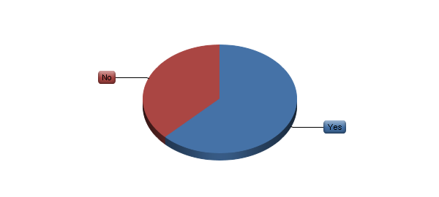

|  |  |  |  |  |  |  |
| --- | --- | --- | --- | --- | --- | --- |
| # | Answer | |  |  | | --- | --- | |  |  | | Response | % |
| 1 | Yes | |  |  | | --- | --- | |  |  | | 20 | 63% |
| 2 | No | |  |  | | --- | --- | |  |  | | 12 | 38% |
|  | Total |  | 32 | 100% |

**III. Summary of Responses – Agencies with Up to 50 Employees (32) (continued)**

12. What software tools do you use for project conclusion? (please choose all that apply)

|  |  |  |  |  |  |  |
| --- | --- | --- | --- | --- | --- | --- |
| # | Answer | |  |  | | --- | --- | |  |  | | Response | % |
| 1 | Proprietary system created by the agency | |  |  | | --- | --- | |  |  | | 7 | 35% |
| 2 | Spreadsheet | |  |  | | --- | --- | |  |  | | 1 | 5% |
| 3 | Advantage (Webvantage) Software | |  |  | | --- | --- | |  |  | | 4 | 20% |
| 4 | Basecamp | |  |  | | --- | --- | |  |  | | 3 | 15% |
| 5 | Clients & Profits | |  |  | | --- | --- | |  |  | | 1 | 5% |
| 6 | Function Point | |  |  | | --- | --- | |  |  | | 0 | 0% |
| 7 | JIRA (Atlassian) | |  |  | | --- | --- | |  |  | | 0 | 0% |
| 8 | MicroSoft Project | |  |  | | --- | --- | |  |  | | 0 | 0% |
| 9 | MicroSoft SharePoint | |  |  | | --- | --- | |  |  | | 1 | 5% |
| 10 | MyProject | |  |  | | --- | --- | |  |  | | 0 | 0% |
| 11 | SocialBridge | |  |  | | --- | --- | |  |  | | 0 | 0% |
| 12 | Streamtime | |  |  | | --- | --- | |  |  | | 0 | 0% |
| 13 | Workamajig | |  |  | | --- | --- | |  |  | | 4 | 20% |
| 14 | Other (please explain) | |  |  | | --- | --- | |  |  | | 5 | 25% |

|  |
| --- |
| Other Tools for Project Conclusion |
| PPT |
| Alfresco |
| Our server – two agencies |
| We have a system to organize electronic files, back them up, and store them. |

**III. Summary of Responses – Agencies with Up to 50 Employees (32) (continued)**

13. Do you use any software tools for any aspects of digital asset management?

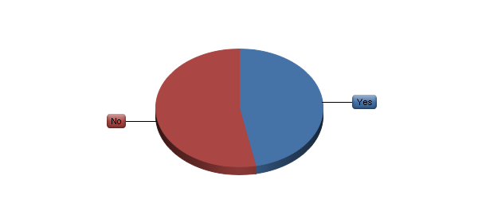

|  |  |  |  |  |  |  |
| --- | --- | --- | --- | --- | --- | --- |
| # | Answer | |  |  | | --- | --- | |  |  | | Response | % |
| 1 | Yes | |  |  | | --- | --- | |  |  | | 15 | 47% |
| 2 | No | |  |  | | --- | --- | |  |  | | 17 | 53% |
|  | Total |  | 32 | 100% |

**III. Summary of Responses – Agencies with Up to 50 Employees (32) (continued)**

14. What software tools do you use for digital asset management? (please choose all that apply)

|  |  |  |  |  |  |  |  |
| --- | --- | --- | --- | --- | --- | --- | --- |
| # | Answer | |  |  | | --- | --- | |  |  | | Response | | % |
| 1 | Proprietary system created by the agency | |  |  | | --- | --- | |  |  | | | 5 | 33% |
| 2 | Spreadsheet | |  |  | | --- | --- | |  |  | | | 6 | 40% |
| 3 | Adobe Bridge | |  |  | | --- | --- | |  |  | | | 1 | 7% |
| 4 | Advantage (Webvantage) Software | |  |  | | --- | --- | |  |  | | | 2 | 13% |
| 5 | Basecamp | |  |  | | --- | --- | |  |  | | | 1 | 7% |
| 6 | Canto Cumulus | |  |  | | --- | --- | |  |  | | | 0 | 0% |
| 7 | DiskTracker | |  |  | | --- | --- | |  |  | | | 0 | 0% |
| 8 | Extensis Portfolio | |  |  | | --- | --- | |  |  | | | 0 | 0% |
| 9 | Function Point | |  |  | | --- | --- | |  |  | | | 0 | 0% |
| 10 | JIRA (Atlassian) | |  |  | | --- | --- | |  |  | | | 0 | 0% |
| 11 | MediaBank | |  |  | | --- | --- | |  |  | | | 0 | 0% |
| 12 | MediaBeacon | |  |  | | --- | --- | |  |  | | | 0 | 0% |
| 13 | MicroSoft Project | |  |  | | --- | --- | |  |  | | | 0 | 0% |
| 14 | MicroSoft SharePoint | |  |  | | --- | --- | |  |  | | | 1 | 7% |
| 15 | MyProject | |  |  | | --- | --- | |  |  | | | 0 | 0% |
| 16 | SocialBridge | |  |  | | --- | --- | |  |  | | | 0 | 0% |
| 17 | Streamtime | |  |  | | --- | --- | |  |  | | | 0 | 0% |
| 18 | Workamajig | |  |  | | --- | --- | |  |  | | | 0 | 0% |
| 19 | Xinet | |  |  | | --- | --- | |  |  | | | 0 | 0% |
| 20 | Other (please explain) | |  |  | | --- | --- | |  |  | | | 7 | 47% |

|  |
| --- |
| Other Tools for Digital Asset Management |
| Dropbox – three agencies |
| Filemaker Database asset usage |
| Files server |
| Alfresco, AdShare |
| We simply make lists as needed of important assets, or see them in electronic folders as final products. |

**III. Summary of Responses – Agencies with Up to 50 Employees (32) (continued)**

15. Please use this space for any additional comments on any project management software tools that you use. Are there any that are particular good? Bad? Difficult to use?

All comments are presented in the All Agencies section, page 22.

**IV. Summary of Responses – Agencies with 51 to 100 Employees (12)**

**There were 12 agencies in this group.**

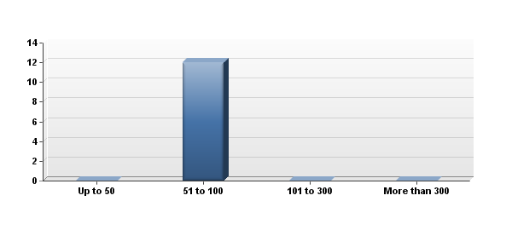

|  |  |  |  |  |  |  |
| --- | --- | --- | --- | --- | --- | --- |
| # | # of Employees | |  |  | | --- | --- | |  |  | | Response | % |
| 1 | Up to 50 | |  |  | | --- | --- | |  |  | | 0 | 0% |
| 2 | 51 to 100 | |  |  | | --- | --- | |  |  | | 12 | 100% |
| 3 | 101 to 300 | |  |  | | --- | --- | |  |  | | 0 | 0% |
| 4 | More than 300 | |  |  | | --- | --- | |  |  | | 0 | 0% |
|  | Total |  | 12 | 100% |

**IV. Summary of Responses – Agencies with 51 to 100 Employees (12) (continued)**

1. Do you use any software tools for any aspects of project workflow?

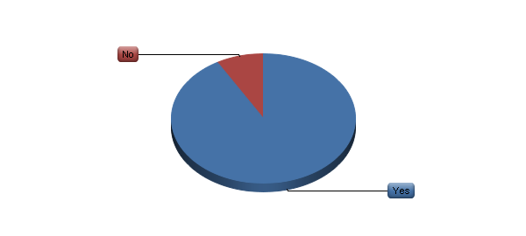

|  |  |  |  |  |  |  |
| --- | --- | --- | --- | --- | --- | --- |
| # | Answer | |  |  | | --- | --- | |  |  | | Response | % |
| 1 | Yes | |  |  | | --- | --- | |  |  | | 11 | 92% |
| 2 | No | |  |  | | --- | --- | |  |  | | 1 | 8% |
|  | Total |  | 12 | 100% |

**IV. Summary of Responses – Agencies with 51 to 100 Employees (12) (continued)**

2. What software tools do you use for project workflow? (please choose all that apply)

|  |  |  |  |  |  |  |
| --- | --- | --- | --- | --- | --- | --- |
| # | Answer | |  |  | | --- | --- | |  |  | | Response | % |
| 1 | Proprietary system created by the agency | |  |  | | --- | --- | |  |  | | 0 | 0% |
| 2 | Spreadsheet | |  |  | | --- | --- | |  |  | | 5 | 45% |
| 3 | Advantage (Webvantage) Software | |  |  | | --- | --- | |  |  | | 3 | 27% |
| 4 | Basecamp | |  |  | | --- | --- | |  |  | | 4 | 36% |
| 5 | Clients & Profits | |  |  | | --- | --- | |  |  | | 1 | 9% |
| 6 | Function Point | |  |  | | --- | --- | |  |  | | 0 | 0% |
| 7 | JIRA (Atlassian) | |  |  | | --- | --- | |  |  | | 1 | 9% |
| 8 | MicroSoft Project | |  |  | | --- | --- | |  |  | | 3 | 27% |
| 9 | MicroSoft SharePoint | |  |  | | --- | --- | |  |  | | 0 | 0% |
| 10 | MyProject | |  |  | | --- | --- | |  |  | | 0 | 0% |
| 11 | SocialBridge | |  |  | | --- | --- | |  |  | | 0 | 0% |
| 12 | Streamtime | |  |  | | --- | --- | |  |  | | 0 | 0% |
| 13 | Workamajig | |  |  | | --- | --- | |  |  | | 4 | 36% |
| 14 | Other (please explain) | |  |  | | --- | --- | |  |  | | 3 | 27% |

|  |
| --- |
| Other Tools for Project Workflow |
| EAS |
| We have purchased Workamajig but have not rolled it out yet. |
| Silent Partner |

**IV. Summary of Responses – Agencies with 51 to 100 Employees (12) (continued)**

3. Do you use any software tools for any aspects of project time management?

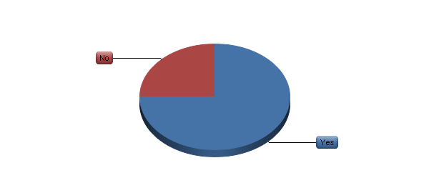

|  |  |  |  |  |  |  |
| --- | --- | --- | --- | --- | --- | --- |
| # | Answer | |  |  | | --- | --- | |  |  | | Response | % |
| 1 | Yes | |  |  | | --- | --- | |  |  | | 9 | 75% |
| 2 | No | |  |  | | --- | --- | |  |  | | 3 | 25% |
|  | Total |  | 12 | 100% |

**IV. Summary of Responses – Agencies with 51 to 100 Employees (12) (continued)**

4. What software tools do you use for project time management? (please choose all that apply)

|  |  |  |  |  |  |  |
| --- | --- | --- | --- | --- | --- | --- |
| # | Answer | |  |  | | --- | --- | |  |  | | Response | % |
| 1 | Proprietary system created by the agency | |  |  | | --- | --- | |  |  | | 0 | 0% |
| 2 | Spreadsheet | |  |  | | --- | --- | |  |  | | 4 | 44% |
| 3 | Advantage (Webvantage) Software | |  |  | | --- | --- | |  |  | | 2 | 22% |
| 4 | Basecamp | |  |  | | --- | --- | |  |  | | 1 | 11% |
| 5 | Clients & Profits | |  |  | | --- | --- | |  |  | | 1 | 11% |
| 6 | Function Point | |  |  | | --- | --- | |  |  | | 0 | 0% |
| 7 | JIRA (Atlassian) | |  |  | | --- | --- | |  |  | | 1 | 11% |
| 8 | MicroSoft Project | |  |  | | --- | --- | |  |  | | 2 | 22% |
| 9 | MicroSoft SharePoint | |  |  | | --- | --- | |  |  | | 0 | 0% |
| 10 | MyProject | |  |  | | --- | --- | |  |  | | 0 | 0% |
| 11 | SocialBridge | |  |  | | --- | --- | |  |  | | 0 | 0% |
| 12 | Streamtime | |  |  | | --- | --- | |  |  | | 0 | 0% |
| 13 | Workamajig | |  |  | | --- | --- | |  |  | | 4 | 44% |
| 14 | Other (please explain) | |  |  | | --- | --- | |  |  | | 2 | 22% |

|  |
| --- |
| Other Tools for Project Time Management |
| We have purchased Workamajig but have not rolled it out yet. |
| Silent Partner |

**IV. Summary of Responses – Agencies with 51 to 100 Employees (12) (continued)**

5. Do you use any software tools for any aspects of project collaboration and approvals?

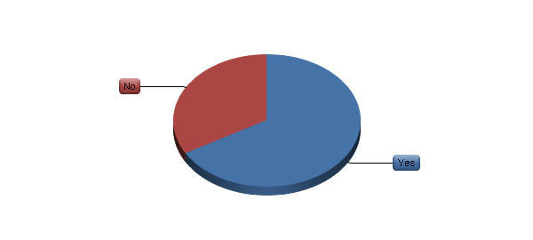

|  |  |  |  |  |  |  |
| --- | --- | --- | --- | --- | --- | --- |
| # | Answer | |  |  | | --- | --- | |  |  | | Response | % |
| 1 | Yes | |  |  | | --- | --- | |  |  | | 8 | 67% |
| 2 | No | |  |  | | --- | --- | |  |  | | 4 | 33% |
|  | Total |  | 12 | 100% |

**IV. Summary of Responses – Agencies with 51 to 100 Employees (12) (continued)**

6. What software tools do you use for project collaboration and approvals? (please choose all that apply)

|  |  |  |  |  |  |  |
| --- | --- | --- | --- | --- | --- | --- |
| # | Answer | |  |  | | --- | --- | |  |  | | Response | % |
| 1 | Proprietary system created by the agency | |  |  | | --- | --- | |  |  | | 0 | 0% |
| 2 | Spreadsheet | |  |  | | --- | --- | |  |  | | 2 | 25% |
| 3 | Advantage (Webvantage) Software | |  |  | | --- | --- | |  |  | | 1 | 13% |
| 4 | Basecamp | |  |  | | --- | --- | |  |  | | 4 | 50% |
| 5 | Clients & Profits | |  |  | | --- | --- | |  |  | | 0 | 0% |
| 6 | Function Point | |  |  | | --- | --- | |  |  | | 0 | 0% |
| 7 | JIRA (Atlassian) | |  |  | | --- | --- | |  |  | | 1 | 13% |
| 8 | MicroSoft Project | |  |  | | --- | --- | |  |  | | 0 | 0% |
| 9 | MicroSoft SharePoint | |  |  | | --- | --- | |  |  | | 0 | 0% |
| 10 | MyProject | |  |  | | --- | --- | |  |  | | 0 | 0% |
| 11 | SocialBridge | |  |  | | --- | --- | |  |  | | 0 | 0% |
| 12 | Streamtime | |  |  | | --- | --- | |  |  | | 0 | 0% |
| 13 | Workamajig | |  |  | | --- | --- | |  |  | | 2 | 25% |
| 14 | Other (please explain) | |  |  | | --- | --- | |  |  | | 4 | 50% |
| 15 | Agency email system | |  |  | | --- | --- | |  |  | | 2 | 25% |

|  |
| --- |
| Other Tools for Collaboration & Approvals |
| Proprietary system created by client |
| BOX |
| Editorially for content collaboration and approval. Also Google docs. |
| Silent Partner |

**IV. Summary of Responses – Agencies with 51 to 100 Employees (12) (continued)**

7. Do you use any software tools for any aspects of project financial management?

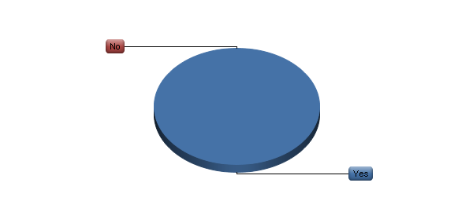

|  |  |  |  |  |  |  |
| --- | --- | --- | --- | --- | --- | --- |
| # | Answer | |  |  | | --- | --- | |  |  | | Response | % |
| 1 | Yes | |  |  | | --- | --- | |  |  | | 12 | 100% |
| 2 | No | |  |  | | --- | --- | |  |  | | 0 | 0% |
|  | Total |  | 12 | 100% |

**IV. Summary of Responses – Agencies with 51 to 100 Employees (12) (continued)**

8. What software tools do you use for project financial management? (please choose all that apply)

|  |  |  |  |  |  |  |
| --- | --- | --- | --- | --- | --- | --- |
| # | Answer | |  |  | | --- | --- | |  |  | | Response | % |
| 1 | Agency accounting system | |  |  | | --- | --- | |  |  | | 2 | 17% |
| 2 | Proprietary system created by the agency | |  |  | | --- | --- | |  |  | | 0 | 0% |
| 3 | Spreadsheet | |  |  | | --- | --- | |  |  | | 6 | 50% |
| 4 | Advantage (Webvantage) Software | |  |  | | --- | --- | |  |  | | 4 | 33% |
| 5 | Basecamp | |  |  | | --- | --- | |  |  | | 0 | 0% |
| 6 | Clients & Profits | |  |  | | --- | --- | |  |  | | 1 | 8% |
| 7 | Function Point | |  |  | | --- | --- | |  |  | | 0 | 0% |
| 8 | JIRA (Atlassian) | |  |  | | --- | --- | |  |  | | 0 | 0% |
| 9 | MicroSoft Project | |  |  | | --- | --- | |  |  | | 0 | 0% |
| 10 | MicroSoft SharePoint | |  |  | | --- | --- | |  |  | | 0 | 0% |
| 11 | MyProject | |  |  | | --- | --- | |  |  | | 0 | 0% |
| 12 | SocialBridge | |  |  | | --- | --- | |  |  | | 0 | 0% |
| 13 | Streamtime | |  |  | | --- | --- | |  |  | | 0 | 0% |
| 14 | Workamajig | |  |  | | --- | --- | |  |  | | 4 | 33% |
| 15 | Other (please explain) | |  |  | | --- | --- | |  |  | | 2 | 17% |

|  |
| --- |
| Other Tools for Project Financial Management |
| EAS |
| We use our financial/timesheet system, currently eSilent Partner. We will be switching to Workamajig in the spring. |

**IV. Summary of Responses – Agencies with 51 to 100 Employees (12) (continued)**

9. Do you use any software tools for any aspects of internal project communications?



|  |  |  |  |  |  |  |
| --- | --- | --- | --- | --- | --- | --- |
| # | Answer | |  |  | | --- | --- | |  |  | | Response | % |
| 1 | Yes | |  |  | | --- | --- | |  |  | | 12 | 100% |
| 2 | No | |  |  | | --- | --- | |  |  | | 0 | 0% |
|  | Total |  | 12 | 100% |

**IV. Summary of Responses – Agencies with 51 to 100 Employees (12) (continued)**

10. What software tools do you use for internal project communications? (please choose all that apply)

|  |  |  |  |  |  |  |
| --- | --- | --- | --- | --- | --- | --- |
| # | Answer | |  |  | | --- | --- | |  |  | | Response | % |
| 1 | Agency email system | |  |  | | --- | --- | |  |  | | 4 | 33% |
| 2 | Proprietary system created by the agency | |  |  | | --- | --- | |  |  | | 0 | 0% |
| 3 | Spreadsheet | |  |  | | --- | --- | |  |  | | 1 | 8% |
| 4 | Advantage (Webvantage) Software | |  |  | | --- | --- | |  |  | | 1 | 8% |
| 5 | Basecamp | |  |  | | --- | --- | |  |  | | 4 | 33% |
| 6 | Clients & Profits | |  |  | | --- | --- | |  |  | | 1 | 8% |
| 7 | Function Point | |  |  | | --- | --- | |  |  | | 0 | 0% |
| 8 | JIRA (Atlassian) | |  |  | | --- | --- | |  |  | | 0 | 0% |
| 9 | MicroSoft Project | |  |  | | --- | --- | |  |  | | 0 | 0% |
| 10 | MicroSoft SharePoint | |  |  | | --- | --- | |  |  | | 0 | 0% |
| 11 | MyProject | |  |  | | --- | --- | |  |  | | 0 | 0% |
| 12 | SocialBridge | |  |  | | --- | --- | |  |  | | 0 | 0% |
| 13 | Streamtime | |  |  | | --- | --- | |  |  | | 0 | 0% |
| 14 | Workamajig | |  |  | | --- | --- | |  |  | | 4 | 33% |
| 15 | Other (please explain) | |  |  | | --- | --- | |  |  | | 4 | 33% |

|  |
| --- |
| Other Tools for Internal Project Communication |
| Outlook |
| BOX |
| EAS |
| Silent Partner |

**IV. Summary of Responses – Agencies with 51 to 100 Employees (12) (continued)**

11. Do you use any software tools for any aspects of project conclusion?



|  |  |  |  |  |  |  |
| --- | --- | --- | --- | --- | --- | --- |
| # | Answer | |  |  | | --- | --- | |  |  | | Response | % |
| 1 | Yes | |  |  | | --- | --- | |  |  | | 8 | 67% |
| 2 | No | |  |  | | --- | --- | |  |  | | 4 | 33% |
|  | Total |  | 12 | 100% |

**IV. Summary of Responses – Agencies with 51 to 100 Employees (12) (continued)**

12. What software tools do you use for project conclusion? (please choose all that apply)

|  |  |  |  |  |  |  |
| --- | --- | --- | --- | --- | --- | --- |
| # | Answer | |  |  | | --- | --- | |  |  | | Response | % |
| 1 | Proprietary system created by the agency | |  |  | | --- | --- | |  |  | | 3 | 38% |
| 2 | Spreadsheet | |  |  | | --- | --- | |  |  | | 0 | 0% |
| 3 | Advantage (Webvantage) Software | |  |  | | --- | --- | |  |  | | 1 | 13% |
| 4 | Basecamp | |  |  | | --- | --- | |  |  | | 2 | 25% |
| 5 | Clients & Profits | |  |  | | --- | --- | |  |  | | 1 | 13% |
| 6 | Function Point | |  |  | | --- | --- | |  |  | | 0 | 0% |
| 7 | JIRA (Atlassian) | |  |  | | --- | --- | |  |  | | 0 | 0% |
| 8 | MicroSoft Project | |  |  | | --- | --- | |  |  | | 0 | 0% |
| 9 | MicroSoft SharePoint | |  |  | | --- | --- | |  |  | | 0 | 0% |
| 10 | MyProject | |  |  | | --- | --- | |  |  | | 0 | 0% |
| 11 | SocialBridge | |  |  | | --- | --- | |  |  | | 0 | 0% |
| 12 | Streamtime | |  |  | | --- | --- | |  |  | | 0 | 0% |
| 13 | Workamajig | |  |  | | --- | --- | |  |  | | 3 | 38% |
| 14 | Other (please explain) | |  |  | | --- | --- | |  |  | | 4 | 50% |

|  |
| --- |
| Other Tools for Project Conclusion |
| Creative Server |
| Dropbox |
| BOX |
| Silent Partner |

**IV. Summary of Responses – Agencies with 51 to 100 Employees (12) (continued)**

13. Do you use any software tools for any aspects of digital asset management?

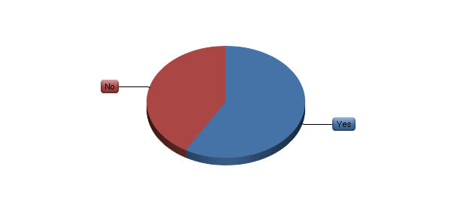

|  |  |  |  |  |  |  |
| --- | --- | --- | --- | --- | --- | --- |
| # | Answer | |  |  | | --- | --- | |  |  | | Response | % |
| 1 | Yes | |  |  | | --- | --- | |  |  | | 7 | 58% |
| 2 | No | |  |  | | --- | --- | |  |  | | 5 | 42% |
|  | Total |  | 12 | 100% |

**IV. Summary of Responses – Agencies with 51 to 100 Employees (12) (continued)**

14. What software tools do you use for digital asset management? (please choose all that apply)

|  |  |  |  |  |  |  |  |
| --- | --- | --- | --- | --- | --- | --- | --- |
| # | Answer | |  |  | | --- | --- | |  |  | | Response | | % |
| 1 | Proprietary system created by the agency | |  |  | | --- | --- | |  |  | | | 1 | 14% |
| 2 | Spreadsheet | |  |  | | --- | --- | |  |  | | | 0 | 0% |
| 3 | Adobe Bridge | |  |  | | --- | --- | |  |  | | | 0 | 0% |
| 4 | Advantage (Webvantage) Software | |  |  | | --- | --- | |  |  | | | 1 | 14% |
| 5 | Basecamp | |  |  | | --- | --- | |  |  | | | 2 | 29% |
| 6 | Canto Cumulus | |  |  | | --- | --- | |  |  | | | 0 | 0% |
| 7 | DiskTracker | |  |  | | --- | --- | |  |  | | | 0 | 0% |
| 8 | Extensis Portfolio | |  |  | | --- | --- | |  |  | | | 0 | 0% |
| 9 | Function Point | |  |  | | --- | --- | |  |  | | | 0 | 0% |
| 10 | JIRA (Atlassian) | |  |  | | --- | --- | |  |  | | | 0 | 0% |
| 11 | MediaBank | |  |  | | --- | --- | |  |  | | | 0 | 0% |
| 12 | MediaBeacon | |  |  | | --- | --- | |  |  | | | 0 | 0% |
| 13 | MicroSoft Project | |  |  | | --- | --- | |  |  | | | 1 | 14% |
| 14 | MicroSoft SharePoint | |  |  | | --- | --- | |  |  | | | 0 | 0% |
| 15 | MyProject | |  |  | | --- | --- | |  |  | | | 0 | 0% |
| 16 | SocialBridge | |  |  | | --- | --- | |  |  | | | 0 | 0% |
| 17 | Streamtime | |  |  | | --- | --- | |  |  | | | 0 | 0% |
| 18 | Workamajig | |  |  | | --- | --- | |  |  | | | 4 | 57% |
| 19 | Xinet | |  |  | | --- | --- | |  |  | | | 1 | 14% |
| 20 | Other (please explain) | |  |  | | --- | --- | |  |  | | | 1 | 14% |

|  |
| --- |
| Other Tools for Digital Asset Management |
| Dropbox |

**IV. Summary of Responses – Agencies with 51 to 100 Employees (12) (continued)**

15. Please use this space for any additional comments on any project management software tools that you use. Are there any that are particular good? Bad? Difficult to use?

All comments are presented in the All Agencies section, page 22.

**V. Summary of Responses – Agencies with 101 to 300 Employees (18)**

**There were 18 agencies in this group.**

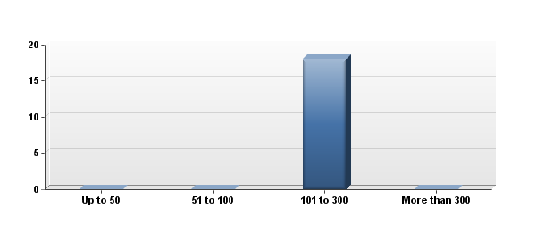

|  |  |  |  |  |  |  |
| --- | --- | --- | --- | --- | --- | --- |
| # | # of Employees | |  |  | | --- | --- | |  |  | | Response | % |
| 1 | Up to 50 | |  |  | | --- | --- | |  |  | | 0 | 0% |
| 2 | 51 to 100 | |  |  | | --- | --- | |  |  | | 12 | 100% |
| 3 | 101 to 300 | |  |  | | --- | --- | |  |  | | 0 | 0% |
| 4 | More than 300 | |  |  | | --- | --- | |  |  | | 0 | 0% |
|  | Total |  | 12 | 100% |

**V. Summary of Responses – Agencies with 101 to 300 Employees (18) (continued)**

1. Do you use any software tools for any aspects of project workflow?

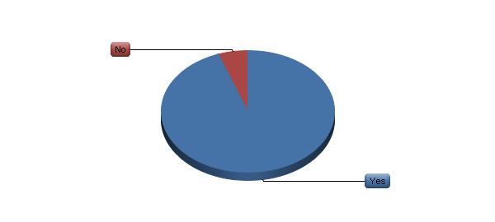

|  |  |  |  |  |  |  |
| --- | --- | --- | --- | --- | --- | --- |
| # | Answer | |  |  | | --- | --- | |  |  | | Response | % |
| 1 | Yes | |  |  | | --- | --- | |  |  | | 17 | 94% |
| 2 | No | |  |  | | --- | --- | |  |  | | 1 | 6% |
|  | Total |  | 18 | 100% |

**V. Summary of Responses – Agencies with 101 to 300 Employees (18) (continued)**

2. What software tools do you use for project workflow? (please choose all that apply)

|  |  |  |  |  |  |  |
| --- | --- | --- | --- | --- | --- | --- |
| # | Answer | |  |  | | --- | --- | |  |  | | Response | % |
| 1 | Proprietary system created by the agency | |  |  | | --- | --- | |  |  | | 6 | 35% |
| 2 | Spreadsheet | |  |  | | --- | --- | |  |  | | 9 | 53% |
| 3 | Advantage (Webvantage) Software | |  |  | | --- | --- | |  |  | | 7 | 41% |
| 4 | Basecamp | |  |  | | --- | --- | |  |  | | 6 | 35% |
| 5 | Clients & Profits | |  |  | | --- | --- | |  |  | | 0 | 0% |
| 6 | Function Point | |  |  | | --- | --- | |  |  | | 0 | 0% |
| 7 | JIRA (Atlassian) | |  |  | | --- | --- | |  |  | | 2 | 12% |
| 8 | MicroSoft Project | |  |  | | --- | --- | |  |  | | 6 | 35% |
| 9 | MicroSoft SharePoint | |  |  | | --- | --- | |  |  | | 3 | 18% |
| 10 | MyProject | |  |  | | --- | --- | |  |  | | 0 | 0% |
| 11 | SocialBridge | |  |  | | --- | --- | |  |  | | 1 | 6% |
| 12 | Streamtime | |  |  | | --- | --- | |  |  | | 0 | 0% |
| 13 | Workamajig | |  |  | | --- | --- | |  |  | | 4 | 24% |
| 14 | Other (please explain) | |  |  | | --- | --- | |  |  | | 3 | 18% |

|  |
| --- |
| Other Tools for Project Workflow |
| Todoist, google docs. |
| Salesforce |
| Confluence (Atlassian) |

**V. Summary of Responses – Agencies with 101 to 300 Employees (18) (continued)**

3. Do you use any software tools for any aspects of project time management?



|  |  |  |  |  |  |  |
| --- | --- | --- | --- | --- | --- | --- |
| # | Answer | |  |  | | --- | --- | |  |  | | Response | % |
| 1 | Yes | |  |  | | --- | --- | |  |  | | 18 | 100% |
| 2 | No | |  |  | | --- | --- | |  |  | | 0 | 0% |
|  | Total |  | 18 | 100% |

**V. Summary of Responses – Agencies with 101 to 300 Employees (18) (continued)**

4. What software tools do you use for project time management? (please choose all that apply)

|  |  |  |  |  |  |  |
| --- | --- | --- | --- | --- | --- | --- |
| # | Answer | |  |  | | --- | --- | |  |  | | Response | % |
| 1 | Proprietary system created by the agency | |  |  | | --- | --- | |  |  | | 4 | 22% |
| 2 | Spreadsheet | |  |  | | --- | --- | |  |  | | 7 | 39% |
| 3 | Advantage (Webvantage) Software | |  |  | | --- | --- | |  |  | | 8 | 44% |
| 4 | Basecamp | |  |  | | --- | --- | |  |  | | 1 | 6% |
| 5 | Clients & Profits | |  |  | | --- | --- | |  |  | | 0 | 0% |
| 6 | Function Point | |  |  | | --- | --- | |  |  | | 0 | 0% |
| 7 | JIRA (Atlassian) | |  |  | | --- | --- | |  |  | | 1 | 6% |
| 8 | MicroSoft Project | |  |  | | --- | --- | |  |  | | 4 | 22% |
| 9 | MicroSoft SharePoint | |  |  | | --- | --- | |  |  | | 1 | 6% |
| 10 | MyProject | |  |  | | --- | --- | |  |  | | 0 | 0% |
| 11 | SocialBridge | |  |  | | --- | --- | |  |  | | 0 | 0% |
| 12 | Streamtime | |  |  | | --- | --- | |  |  | | 0 | 0% |
| 13 | Workamajig | |  |  | | --- | --- | |  |  | | 4 | 22% |
| 14 | Other (please explain) | |  |  | | --- | --- | |  |  | | 1 | 6% |

|  |
| --- |
| Other Tools for Project Time Management |
| Salesforce |

**V. Summary of Responses – Agencies with 101 to 300 Employees (18) (continued)**

5. Do you use any software tools for any aspects of project collaboration and approvals?

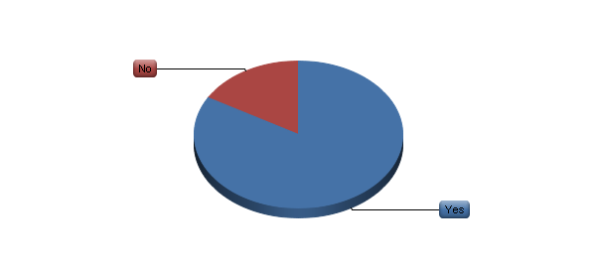

|  |  |  |  |  |  |  |
| --- | --- | --- | --- | --- | --- | --- |
| # | Answer | |  |  | | --- | --- | |  |  | | Response | % |
| 1 | Yes | |  |  | | --- | --- | |  |  | | 15 | 83% |
| 2 | No | |  |  | | --- | --- | |  |  | | 3 | 17% |
|  | Total |  | 18 | 100% |

**V. Summary of Responses – Agencies with 101 to 300 Employees (18) (continued)**

6. What software tools do you use for project collaboration and approvals? (please choose all that apply)

|  |  |  |  |  |  |  |
| --- | --- | --- | --- | --- | --- | --- |
| # | Answer | |  |  | | --- | --- | |  |  | | Response | % |
| 1 | Proprietary system created by the agency | |  |  | | --- | --- | |  |  | | 2 | 13% |
| 2 | Spreadsheet | |  |  | | --- | --- | |  |  | | 2 | 13% |
| 3 | Advantage (Webvantage) Software | |  |  | | --- | --- | |  |  | | 3 | 20% |
| 4 | Basecamp | |  |  | | --- | --- | |  |  | | 3 | 20% |
| 5 | Clients & Profits | |  |  | | --- | --- | |  |  | | 0 | 0% |
| 6 | Function Point | |  |  | | --- | --- | |  |  | | 0 | 0% |
| 7 | JIRA (Atlassian) | |  |  | | --- | --- | |  |  | | 0 | 0% |
| 8 | MicroSoft Project | |  |  | | --- | --- | |  |  | | 0 | 0% |
| 9 | MicroSoft SharePoint | |  |  | | --- | --- | |  |  | | 3 | 20% |
| 10 | MyProject | |  |  | | --- | --- | |  |  | | 0 | 0% |
| 11 | SocialBridge | |  |  | | --- | --- | |  |  | | 1 | 7% |
| 12 | Streamtime | |  |  | | --- | --- | |  |  | | 0 | 0% |
| 13 | Workamajig | |  |  | | --- | --- | |  |  | | 3 | 20% |
| 14 | Other (please explain) | |  |  | | --- | --- | |  |  | | 6 | 40% |
| 15 | Agency email system | |  |  | | --- | --- | |  |  | | 3 | 20% |

|  |
| --- |
| Other Tools for Collaboration & Approvals |
| ProofHQ for creative proofing and approval |
| This is a mix, based on client team/clients |
| Xinet / Web Native, Wiredrive (for broadcast) |
| Salesforce |
| Confluence (Atlassian) |
| Email |

**V. Summary of Responses – Agencies with 101 to 300 Employees (18) (continued)**

7. Do you use any software tools for any aspects of project financial management?



|  |  |  |  |  |  |  |
| --- | --- | --- | --- | --- | --- | --- |
| # | Answer | |  |  | | --- | --- | |  |  | | Response | % |
| 1 | Yes | |  |  | | --- | --- | |  |  | | 17 | 94% |
| 2 | No | |  |  | | --- | --- | |  |  | | 1 | 6% |
|  | Total |  | 18 | 100% |

**V. Summary of Responses – Agencies with 101 to 300 Employees (18) (continued)**

8. What software tools do you use for project financial management? (please choose all that apply)

|  |  |  |  |  |  |  |
| --- | --- | --- | --- | --- | --- | --- |
| # | Answer | |  |  | | --- | --- | |  |  | | Response | % |
| 1 | Agency accounting system | |  |  | | --- | --- | |  |  | | 3 | 18% |
| 2 | Proprietary system created by the agency | |  |  | | --- | --- | |  |  | | 2 | 12% |
| 3 | Spreadsheet | |  |  | | --- | --- | |  |  | | 9 | 53% |
| 4 | Advantage (Webvantage) Software | |  |  | | --- | --- | |  |  | | 8 | 47% |
| 5 | Basecamp | |  |  | | --- | --- | |  |  | | 0 | 0% |
| 6 | Clients & Profits | |  |  | | --- | --- | |  |  | | 0 | 0% |
| 7 | Function Point | |  |  | | --- | --- | |  |  | | 0 | 0% |
| 8 | JIRA (Atlassian) | |  |  | | --- | --- | |  |  | | 0 | 0% |
| 9 | MicroSoft Project | |  |  | | --- | --- | |  |  | | 0 | 0% |
| 10 | MicroSoft SharePoint | |  |  | | --- | --- | |  |  | | 0 | 0% |
| 11 | MyProject | |  |  | | --- | --- | |  |  | | 0 | 0% |
| 12 | SocialBridge | |  |  | | --- | --- | |  |  | | 0 | 0% |
| 13 | Streamtime | |  |  | | --- | --- | |  |  | | 0 | 0% |
| 14 | Workamajig | |  |  | | --- | --- | |  |  | | 4 | 24% |
| 15 | Other (please explain) | |  |  | | --- | --- | |  |  | | 3 | 18% |

|  |
| --- |
| Other Tools for Project Financial Management |
| We use the Advantage Financial software and export our reports |
| Google docs. |
| Solomon |

**V. Summary of Responses – Agencies with 101 to 300 Employees (18) (continued)**

9. Do you use any software tools for any aspects of internal project communications?



|  |  |  |  |  |  |  |
| --- | --- | --- | --- | --- | --- | --- |
| # | Answer | |  |  | | --- | --- | |  |  | | Response | % |
| 1 | Yes | |  |  | | --- | --- | |  |  | | 15 | 83% |
| 2 | No | |  |  | | --- | --- | |  |  | | 3 | 17% |
|  | Total |  | 18 | 100% |

**V. Summary of Responses – Agencies with 101 to 300 Employees (18) (continued)**

10. What software tools do you use for internal project communications? (please choose all that apply)

|  |  |  |  |  |  |  |
| --- | --- | --- | --- | --- | --- | --- |
| # | Answer | |  |  | | --- | --- | |  |  | | Response | % |
| 1 | Agency email system | |  |  | | --- | --- | |  |  | | 3 | 20% |
| 2 | Proprietary system created by the agency | |  |  | | --- | --- | |  |  | | 4 | 27% |
| 3 | Spreadsheet | |  |  | | --- | --- | |  |  | | 3 | 20% |
| 4 | Advantage (Webvantage) Software | |  |  | | --- | --- | |  |  | | 6 | 40% |
| 5 | Basecamp | |  |  | | --- | --- | |  |  | | 3 | 20% |
| 6 | Clients & Profits | |  |  | | --- | --- | |  |  | | 0 | 0% |
| 7 | Function Point | |  |  | | --- | --- | |  |  | | 0 | 0% |
| 8 | JIRA (Atlassian) | |  |  | | --- | --- | |  |  | | 0 | 0% |
| 9 | MicroSoft Project | |  |  | | --- | --- | |  |  | | 0 | 0% |
| 10 | MicroSoft SharePoint | |  |  | | --- | --- | |  |  | | 2 | 13% |
| 11 | MyProject | |  |  | | --- | --- | |  |  | | 0 | 0% |
| 12 | SocialBridge | |  |  | | --- | --- | |  |  | | 0 | 0% |
| 13 | Streamtime | |  |  | | --- | --- | |  |  | | 0 | 0% |
| 14 | Workamajig | |  |  | | --- | --- | |  |  | | 2 | 13% |
| 15 | Other (please explain) | |  |  | | --- | --- | |  |  | | 3 | 20% |

|  |
| --- |
| Other Tools for Internal Project Communication |
| Salesforce |
| Confluence (Atlassian) |
| Email |

**V. Summary of Responses – Agencies with 101 to 300 Employees (18) (continued)**

11. Do you use any software tools for any aspects of project conclusion?

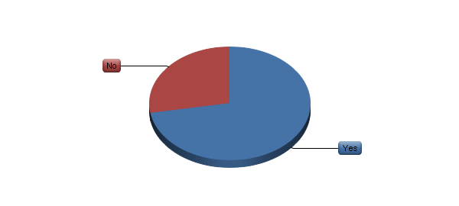

|  |  |  |  |  |  |  |
| --- | --- | --- | --- | --- | --- | --- |
| # | Answer | |  |  | | --- | --- | |  |  | | Response | % |
| 1 | Yes | |  |  | | --- | --- | |  |  | | 13 | 72% |
| 2 | No | |  |  | | --- | --- | |  |  | | 5 | 28% |
|  | Total |  | 18 | 100% |

**V. Summary of Responses – Agencies with 101 to 300 Employees (18) (continued)**

12. What software tools do you use for project conclusion? (please choose all that apply)

|  |  |  |  |  |  |  |
| --- | --- | --- | --- | --- | --- | --- |
| # | Answer | |  |  | | --- | --- | |  |  | | Response | % |
| 1 | Proprietary system created by the agency | |  |  | | --- | --- | |  |  | | 3 | 23% |
| 2 | Spreadsheet | |  |  | | --- | --- | |  |  | | 0 | 0% |
| 3 | Advantage (Webvantage) Software | |  |  | | --- | --- | |  |  | | 3 | 23% |
| 4 | Basecamp | |  |  | | --- | --- | |  |  | | 2 | 15% |
| 5 | Clients & Profits | |  |  | | --- | --- | |  |  | | 0 | 0% |
| 6 | Function Point | |  |  | | --- | --- | |  |  | | 0 | 0% |
| 7 | JIRA (Atlassian) | |  |  | | --- | --- | |  |  | | 0 | 0% |
| 8 | MicroSoft Project | |  |  | | --- | --- | |  |  | | 0 | 0% |
| 9 | MicroSoft SharePoint | |  |  | | --- | --- | |  |  | | 2 | 15% |
| 10 | MyProject | |  |  | | --- | --- | |  |  | | 0 | 0% |
| 11 | SocialBridge | |  |  | | --- | --- | |  |  | | 1 | 8% |
| 12 | Streamtime | |  |  | | --- | --- | |  |  | | 0 | 0% |
| 13 | Workamajig | |  |  | | --- | --- | |  |  | | 1 | 8% |
| 14 | Other (please explain) | |  |  | | --- | --- | |  |  | | 8 | 62% |

|  |
| --- |
| Other Tools for Project Conclusion |
| Google docs. |
| Salesforce |
| Confluence (Atlassian) |
| Egnyte |
| Server – four agencies |

**V. Summary of Responses – Agencies with 101 to 300 Employees (18) (continued)**

13. Do you use any software tools for any aspects of digital asset management?



|  |  |  |  |  |  |  |
| --- | --- | --- | --- | --- | --- | --- |
| # | Answer | |  |  | | --- | --- | |  |  | | Response | % |
| 1 | Yes | |  |  | | --- | --- | |  |  | | 12 | 67% |
| 2 | No | |  |  | | --- | --- | |  |  | | 6 | 33% |
|  | Total |  | 18 | 100% |

**V. Summary of Responses – Agencies with 101 to 300 Employees (18) (continued)**

14. What software tools do you use for digital asset management? (please choose all that apply)

|  |  |  |  |  |  |  |  |
| --- | --- | --- | --- | --- | --- | --- | --- |
| # | Answer | |  |  | | --- | --- | |  |  | | Response | | % |
| 1 | Proprietary system created by the agency | |  |  | | --- | --- | |  |  | | | 3 | 25% |
| 2 | Spreadsheet | |  |  | | --- | --- | |  |  | | | 2 | 17% |
| 3 | Adobe Bridge | |  |  | | --- | --- | |  |  | | | 1 | 8% |
| 4 | Advantage (Webvantage) Software | |  |  | | --- | --- | |  |  | | | 2 | 17% |
| 5 | Basecamp | |  |  | | --- | --- | |  |  | | | 1 | 8% |
| 6 | Canto Cumulus | |  |  | | --- | --- | |  |  | | | 0 | 0% |
| 7 | DiskTracker | |  |  | | --- | --- | |  |  | | | 0 | 0% |
| 8 | Extensis Portfolio | |  |  | | --- | --- | |  |  | | | 3 | 25% |
| 9 | Function Point | |  |  | | --- | --- | |  |  | | | 0 | 0% |
| 10 | JIRA (Atlassian) | |  |  | | --- | --- | |  |  | | | 0 | 0% |
| 11 | MediaBank | |  |  | | --- | --- | |  |  | | | 0 | 0% |
| 12 | MediaBeacon | |  |  | | --- | --- | |  |  | | | 1 | 8% |
| 13 | MicroSoft Project | |  |  | | --- | --- | |  |  | | | 0 | 0% |
| 14 | MicroSoft SharePoint | |  |  | | --- | --- | |  |  | | | 2 | 17% |
| 15 | MyProject | |  |  | | --- | --- | |  |  | | | 0 | 0% |
| 16 | SocialBridge | |  |  | | --- | --- | |  |  | | | 0 | 0% |
| 17 | Streamtime | |  |  | | --- | --- | |  |  | | | 0 | 0% |
| 18 | Workamajig | |  |  | | --- | --- | |  |  | | | 1 | 8% |
| 19 | Xinet | |  |  | | --- | --- | |  |  | | | 1 | 8% |
| 20 | Other (please explain) | |  |  | | --- | --- | |  |  | | | 2 | 17% |

|  |
| --- |
| Other Tools for Digital Asset Management |
| Confluence (Atlassian) |

**V. Summary of Responses – Agencies with 101 to 300 Employees (18) (continued)**

15. Please use this space for any additional comments on any project management software tools that you use. Are there any that are particular good? Bad? Difficult to use?

All comments are presented in the All Agencies section, page 22.

**VI. Summary of Responses – Agencies with More Than 300 Employees (18)**

**There were 18 agencies in this group.**

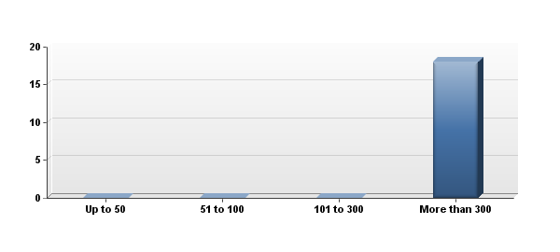

|  |  |  |  |  |  |  |
| --- | --- | --- | --- | --- | --- | --- |
| # | # of Employees | |  |  | | --- | --- | |  |  | | Response | % |
| 1 | Up to 50 | |  |  | | --- | --- | |  |  | | 0 | 0% |
| 2 | 51 to 100 | |  |  | | --- | --- | |  |  | | 0 | 0% |
| 3 | 101 to 300 | |  |  | | --- | --- | |  |  | | 0 | 0% |
| 4 | More than 300 | |  |  | | --- | --- | |  |  | | 18 | 100% |
|  | Total |  | 18 | 100% |

**VI. Summary of Responses – Agencies with More Than 300 Employees (18) (continued)**

1. Do you use any software tools for any aspects of project workflow?



|  |  |  |  |  |  |  |
| --- | --- | --- | --- | --- | --- | --- |
| # | Answer | |  |  | | --- | --- | |  |  | | Response | % |
| 1 | Yes | |  |  | | --- | --- | |  |  | | 15 | 83% |
| 2 | No | |  |  | | --- | --- | |  |  | | 3 | 17% |
|  | Total |  | 18 | 100% |

**VI. Summary of Responses – Agencies with More Than 300 Employees (18) (continued)**

2. What software tools do you use for project workflow? (please choose all that apply)

|  |  |  |  |  |  |  |
| --- | --- | --- | --- | --- | --- | --- |
| # | Answer | |  |  | | --- | --- | |  |  | | Response | % |
| 1 | Proprietary system created by the agency | |  |  | | --- | --- | |  |  | | 5 | 33% |
| 2 | Spreadsheet | |  |  | | --- | --- | |  |  | | 12 | 80% |
| 3 | Advantage (Webvantage) Software | |  |  | | --- | --- | |  |  | | 0 | 0% |
| 4 | Basecamp | |  |  | | --- | --- | |  |  | | 5 | 33% |
| 5 | Clients & Profits | |  |  | | --- | --- | |  |  | | 1 | 7% |
| 6 | Function Point | |  |  | | --- | --- | |  |  | | 0 | 0% |
| 7 | JIRA (Atlassian) | |  |  | | --- | --- | |  |  | | 7 | 47% |
| 8 | MicroSoft Project | |  |  | | --- | --- | |  |  | | 7 | 47% |
| 9 | MicroSoft SharePoint | |  |  | | --- | --- | |  |  | | 7 | 47% |
| 10 | MyProject | |  |  | | --- | --- | |  |  | | 0 | 0% |
| 11 | SocialBridge | |  |  | | --- | --- | |  |  | | 0 | 0% |
| 12 | Streamtime | |  |  | | --- | --- | |  |  | | 0 | 0% |
| 13 | Workamajig | |  |  | | --- | --- | |  |  | | 0 | 0% |
| 14 | Other (please explain) | |  |  | | --- | --- | |  |  | | 4 | 27% |

|  |
| --- |
| Other Tools for Project Workflow |
| We also work with Farmer & Co to track scope. They have a custom tool. |
| A customized version of Job Charge; also FastTrack |
| Request Tracker (RT), Box, Wiki |
| Confluence (Atlassian product) |

**VI. Summary of Responses – Agencies with More Than 300 Employees (18) (continued)**

3. Do you use any software tools for any aspects of project time management?



|  |  |  |  |  |  |  |
| --- | --- | --- | --- | --- | --- | --- |
| # | Answer | |  |  | | --- | --- | |  |  | | Response | % |
| 1 | Yes | |  |  | | --- | --- | |  |  | | 15 | 83% |
| 2 | No | |  |  | | --- | --- | |  |  | | 3 | 17% |
|  | Total |  | 18 | 100% |

**VI. Summary of Responses – Agencies with More Than 300 Employees (18) (continued)**

4. What software tools do you use for project time management? (please choose all that apply)

|  |  |  |  |  |  |  |
| --- | --- | --- | --- | --- | --- | --- |
| # | Answer | |  |  | | --- | --- | |  |  | | Response | % |
| 1 | Proprietary system created by the agency | |  |  | | --- | --- | |  |  | | 6 | 40% |
| 2 | Spreadsheet | |  |  | | --- | --- | |  |  | | 8 | 53% |
| 3 | Advantage (Webvantage) Software | |  |  | | --- | --- | |  |  | | 0 | 0% |
| 4 | Basecamp | |  |  | | --- | --- | |  |  | | 0 | 0% |
| 5 | Clients & Profits | |  |  | | --- | --- | |  |  | | 1 | 7% |
| 6 | Function Point | |  |  | | --- | --- | |  |  | | 0 | 0% |
| 7 | JIRA (Atlassian) | |  |  | | --- | --- | |  |  | | 2 | 13% |
| 8 | MicroSoft Project | |  |  | | --- | --- | |  |  | | 6 | 40% |
| 9 | MicroSoft SharePoint | |  |  | | --- | --- | |  |  | | 3 | 20% |
| 10 | MyProject | |  |  | | --- | --- | |  |  | | 0 | 0% |
| 11 | SocialBridge | |  |  | | --- | --- | |  |  | | 0 | 0% |
| 12 | Streamtime | |  |  | | --- | --- | |  |  | | 0 | 0% |
| 13 | Workamajig | |  |  | | --- | --- | |  |  | | 0 | 0% |
| 14 | Other (please explain) | |  |  | | --- | --- | |  |  | | 3 | 20% |

|  |
| --- |
| Other Tools for Project Time Management |
| FastTrack |
| SmartSheet |
| Prism |

**VI. Summary of Responses – Agencies with More Than 300 Employees (18) (continued)**

5. Do you use any software tools for any aspects of project collaboration and approvals?



|  |  |  |  |  |  |  |
| --- | --- | --- | --- | --- | --- | --- |
| # | Answer | |  |  | | --- | --- | |  |  | | Response | % |
| 1 | Yes | |  |  | | --- | --- | |  |  | | 13 | 72% |
| 2 | No | |  |  | | --- | --- | |  |  | | 5 | 28% |
|  | Total |  | 18 | 100% |

**VI. Summary of Responses – Agencies with More Than 300 Employees (18) (continued)**

6. What software tools do you use for project collaboration and approvals? (please choose all that apply)

|  |  |  |  |  |  |  |
| --- | --- | --- | --- | --- | --- | --- |
| # | Answer | |  |  | | --- | --- | |  |  | | Response | % |
| 1 | Proprietary system created by the agency | |  |  | | --- | --- | |  |  | | 4 | 31% |
| 2 | Spreadsheet | |  |  | | --- | --- | |  |  | | 6 | 46% |
| 3 | Advantage (Webvantage) Software | |  |  | | --- | --- | |  |  | | 0 | 0% |
| 4 | Basecamp | |  |  | | --- | --- | |  |  | | 4 | 31% |
| 5 | Clients & Profits | |  |  | | --- | --- | |  |  | | 0 | 0% |
| 6 | Function Point | |  |  | | --- | --- | |  |  | | 0 | 0% |
| 7 | JIRA (Atlassian) | |  |  | | --- | --- | |  |  | | 3 | 23% |
| 8 | MicroSoft Project | |  |  | | --- | --- | |  |  | | 0 | 0% |
| 9 | MicroSoft SharePoint | |  |  | | --- | --- | |  |  | | 1 | 8% |
| 10 | MyProject | |  |  | | --- | --- | |  |  | | 0 | 0% |
| 11 | SocialBridge | |  |  | | --- | --- | |  |  | | 0 | 0% |
| 12 | Streamtime | |  |  | | --- | --- | |  |  | | 0 | 0% |
| 13 | Workamajig | |  |  | | --- | --- | |  |  | | 0 | 0% |
| 14 | Other (please explain) | |  |  | | --- | --- | |  |  | | 7 | 54% |
| 15 | Agency email system | |  |  | | --- | --- | |  |  | | 7 | 54% |

|  |
| --- |
| Other Tools for Collaboration & Approvals |
| Secure File Share |
| Dalim |
| BOX |
| Box, Proof HQ |
| Our soft proofing system for color and content is called SmartView and it is powered by Kodak Approval. |
| Network drive, printed routing, this is an area we are looking to improve. Approvals are still very manual. |
| Confluence - part of JIRA |

**VI. Summary of Responses – Agencies with More Than 300 Employees (18) (continued)**

7. Do you use any software tools for any aspects of project financial management?



|  |  |  |  |  |  |  |
| --- | --- | --- | --- | --- | --- | --- |
| # | Answer | |  |  | | --- | --- | |  |  | | Response | % |
| 1 | Yes | |  |  | | --- | --- | |  |  | | 15 | 83% |
| 2 | No | |  |  | | --- | --- | |  |  | | 3 | 17% |
|  | Total |  | 18 | 100% |

**VI. Summary of Responses – Agencies with More Than 300 Employees (18) (continued)**

8. What software tools do you use for project financial management? (please choose all that apply)

|  |  |  |  |  |  |  |
| --- | --- | --- | --- | --- | --- | --- |
| # | Answer | |  |  | | --- | --- | |  |  | | Response | % |
| 1 | Agency accounting system | |  |  | | --- | --- | |  |  | | 11 | 73% |
| 2 | Proprietary system created by the agency | |  |  | | --- | --- | |  |  | | 6 | 40% |
| 3 | Spreadsheet | |  |  | | --- | --- | |  |  | | 11 | 73% |
| 4 | Advantage (Webvantage) Software | |  |  | | --- | --- | |  |  | | 0 | 0% |
| 5 | Basecamp | |  |  | | --- | --- | |  |  | | 0 | 0% |
| 6 | Clients & Profits | |  |  | | --- | --- | |  |  | | 1 | 7% |
| 7 | Function Point | |  |  | | --- | --- | |  |  | | 0 | 0% |
| 8 | JIRA (Atlassian) | |  |  | | --- | --- | |  |  | | 0 | 0% |
| 9 | MicroSoft Project | |  |  | | --- | --- | |  |  | | 0 | 0% |
| 10 | MicroSoft SharePoint | |  |  | | --- | --- | |  |  | | 0 | 0% |
| 11 | MyProject | |  |  | | --- | --- | |  |  | | 0 | 0% |
| 12 | SocialBridge | |  |  | | --- | --- | |  |  | | 0 | 0% |
| 13 | Streamtime | |  |  | | --- | --- | |  |  | | 0 | 0% |
| 14 | Workamajig | |  |  | | --- | --- | |  |  | | 0 | 0% |
| 15 | Other (please explain) | |  |  | | --- | --- | |  |  | | 3 | 20% |

|  |
| --- |
| Other Tools for Project Financial Management |
| EAS and Cognos |
| EAS |
| Mediaplex |

**VI. Summary of Responses – Agencies with More Than 300 Employees (18) (continued)**

9. Do you use any software tools for any aspects of internal project communications?



|  |  |  |  |  |  |  |
| --- | --- | --- | --- | --- | --- | --- |
| # | Answer | |  |  | | --- | --- | |  |  | | Response | % |
| 1 | Yes | |  |  | | --- | --- | |  |  | | 12 | 67% |
| 2 | No | |  |  | | --- | --- | |  |  | | 6 | 33% |
|  | Total |  | 18 | 100% |

**VI. Summary of Responses – Agencies with More Than 300 Employees (18) (continued)**

10. What software tools do you use for internal project communications? (please choose all that apply)

|  |  |  |  |  |  |  |
| --- | --- | --- | --- | --- | --- | --- |
| # | Answer | |  |  | | --- | --- | |  |  | | Response | % |
| 1 | Agency email system | |  |  | | --- | --- | |  |  | | 8 | 67% |
| 2 | Proprietary system created by the agency | |  |  | | --- | --- | |  |  | | 4 | 33% |
| 3 | Spreadsheet | |  |  | | --- | --- | |  |  | | 4 | 33% |
| 4 | Advantage (Webvantage) Software | |  |  | | --- | --- | |  |  | | 0 | 0% |
| 5 | Basecamp | |  |  | | --- | --- | |  |  | | 2 | 17% |
| 6 | Clients & Profits | |  |  | | --- | --- | |  |  | | 0 | 0% |
| 7 | Function Point | |  |  | | --- | --- | |  |  | | 0 | 0% |
| 8 | JIRA (Atlassian) | |  |  | | --- | --- | |  |  | | 4 | 33% |
| 9 | MicroSoft Project | |  |  | | --- | --- | |  |  | | 1 | 8% |
| 10 | MicroSoft SharePoint | |  |  | | --- | --- | |  |  | | 3 | 25% |
| 11 | MyProject | |  |  | | --- | --- | |  |  | | 0 | 0% |
| 12 | SocialBridge | |  |  | | --- | --- | |  |  | | 0 | 0% |
| 13 | Streamtime | |  |  | | --- | --- | |  |  | | 0 | 0% |
| 14 | Workamajig | |  |  | | --- | --- | |  |  | | 0 | 0% |
| 15 | Other (please explain) | |  |  | | --- | --- | |  |  | | 6 | 50% |

|  |
| --- |
| Other Tools for Internal Project Communication |
| Confluence (wiki) |
| Dalim |
| iChat, AIM |
| Confluence and EAS Job Change Log |
| Box.com |
| JMS |

**VI. Summary of Responses – Agencies with More Than 300 Employees (18) (continued)**

11. Do you use any software tools for any aspects of project conclusion?

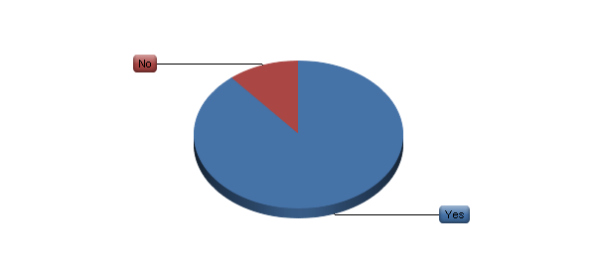

|  |  |  |  |  |  |  |
| --- | --- | --- | --- | --- | --- | --- |
| # | Answer | |  |  | | --- | --- | |  |  | | Response | % |
| 1 | Yes | |  |  | | --- | --- | |  |  | | 16 | 89% |
| 2 | No | |  |  | | --- | --- | |  |  | | 2 | 11% |
|  | Total |  | 18 | 100% |

**VI. Summary of Responses – Agencies with More Than 300 Employees (18) (continued)**

12. What software tools do you use for project conclusion? (please choose all that apply)

|  |  |  |  |  |  |  |
| --- | --- | --- | --- | --- | --- | --- |
| # | Answer | |  |  | | --- | --- | |  |  | | Response | % |
| 1 | Proprietary system created by the agency | |  |  | | --- | --- | |  |  | | 8 | 50% |
| 2 | Spreadsheet | |  |  | | --- | --- | |  |  | | 2 | 13% |
| 3 | Advantage (Webvantage) Software | |  |  | | --- | --- | |  |  | | 0 | 0% |
| 4 | Basecamp | |  |  | | --- | --- | |  |  | | 1 | 6% |
| 5 | Clients & Profits | |  |  | | --- | --- | |  |  | | 0 | 0% |
| 6 | Function Point | |  |  | | --- | --- | |  |  | | 0 | 0% |
| 7 | JIRA (Atlassian) | |  |  | | --- | --- | |  |  | | 2 | 13% |
| 8 | MicroSoft Project | |  |  | | --- | --- | |  |  | | 0 | 0% |
| 9 | MicroSoft SharePoint | |  |  | | --- | --- | |  |  | | 3 | 19% |
| 10 | MyProject | |  |  | | --- | --- | |  |  | | 0 | 0% |
| 11 | SocialBridge | |  |  | | --- | --- | |  |  | | 0 | 0% |
| 12 | Streamtime | |  |  | | --- | --- | |  |  | | 0 | 0% |
| 13 | Workamajig | |  |  | | --- | --- | |  |  | | 0 | 0% |
| 14 | Other (please explain) | |  |  | | --- | --- | |  |  | | 8 | 50% |

|  |
| --- |
| Other Tools for Project Conclusion |
| Set project wrap up tasks + post mortem template |
| Dalim |
| BOX |
| Server – two agencies |
| EAS, Confluence |
| JMS |
| Network drives for archiving, an area where could improve greatly in |

**VI. Summary of Responses – Agencies with More Than 300 Employees (18) (continued)**

13. Do you use any software tools for any aspects of digital asset management?

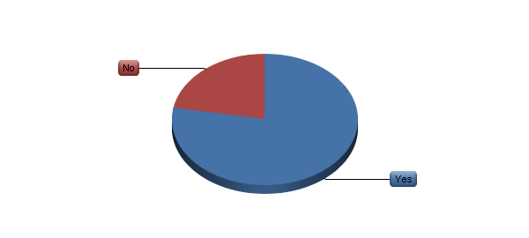

|  |  |  |  |  |  |  |
| --- | --- | --- | --- | --- | --- | --- |
| # | Answer | |  |  | | --- | --- | |  |  | | Response | % |
| 1 | Yes | |  |  | | --- | --- | |  |  | | 14 | 78% |
| 2 | No | |  |  | | --- | --- | |  |  | | 4 | 22% |
|  | Total |  | 18 | 100% |

**VI. Summary of Responses – Agencies with More Than 300 Employees (18) (continued)**

14. What software tools do you use for digital asset management? (please choose all that apply)

|  |  |  |  |  |  |  |  |
| --- | --- | --- | --- | --- | --- | --- | --- |
| # | Answer | |  |  | | --- | --- | |  |  | | Response | | % |
| 1 | Proprietary system created by the agency | |  |  | | --- | --- | |  |  | | | 7 | 50% |
| 2 | Spreadsheet | |  |  | | --- | --- | |  |  | | | 1 | 7% |
| 3 | Adobe Bridge | |  |  | | --- | --- | |  |  | | | 0 | 0% |
| 4 | Advantage (Webvantage) Software | |  |  | | --- | --- | |  |  | | | 0 | 0% |
| 5 | Basecamp | |  |  | | --- | --- | |  |  | | | 0 | 0% |
| 6 | Canto Cumulus | |  |  | | --- | --- | |  |  | | | 0 | 0% |
| 7 | DiskTracker | |  |  | | --- | --- | |  |  | | | 0 | 0% |
| 8 | Extensis Portfolio | |  |  | | --- | --- | |  |  | | | 0 | 0% |
| 9 | Function Point | |  |  | | --- | --- | |  |  | | | 0 | 0% |
| 10 | JIRA (Atlassian) | |  |  | | --- | --- | |  |  | | | 0 | 0% |
| 11 | MediaBank | |  |  | | --- | --- | |  |  | | | 0 | 0% |
| 12 | MediaBeacon | |  |  | | --- | --- | |  |  | | | 0 | 0% |
| 13 | MicroSoft Project | |  |  | | --- | --- | |  |  | | | 0 | 0% |
| 14 | MicroSoft SharePoint | |  |  | | --- | --- | |  |  | | | 1 | 7% |
| 15 | MyProject | |  |  | | --- | --- | |  |  | | | 0 | 0% |
| 16 | SocialBridge | |  |  | | --- | --- | |  |  | | | 0 | 0% |
| 17 | Streamtime | |  |  | | --- | --- | |  |  | | | 0 | 0% |
| 18 | Workamajig | |  |  | | --- | --- | |  |  | | | 0 | 0% |
| 19 | Xinet | |  |  | | --- | --- | |  |  | | | 9 | 64% |
| 20 | Other (please explain) | |  |  | | --- | --- | |  |  | | | 2 | 14% |

|  |
| --- |
| Other Tools for Digital Asset Management |
| Also use JobCharge to gather metadata |
| Server (BOX) |

**VI. Summary of Responses – Agencies with More Than 300 Employees (18) (continued)**

15. Please use this space for any additional comments on any project management software tools that you use. Are there any that are particular good? Bad? Difficult to use?

All comments are presented in the All Agencies section, page 22.